INTERNATIONAL ASSOCIATION OF PLUMBING AND MECHANICAL OFFICIALS
UNIFORM EVALUATION SERVICES

EVALUATION CRITERIA FOR

Modified Base Test Method for Open–Web Steel Joists Supporting a Standing Seam Roof System

EC031-2017
(Adopted November 2017)

- INTRODUCTION

  - Purpose:

This Evaluation Criteria establishes a test method that provides the requirements for quantifying the lateral bracing provided to open-web steel joists from standing seam roof systems to be recognized in an evaluation report independently reviewed by an evaluation service agency under the 2018, 2015 and 2012 International Building Code® (IBC). Basis of recognition is IBC Section 104.11.

Due to the variability in configuration and construction of standing seam roof systems and their attachments, it is not practical to develop a generic method to predict the interaction of a particular standing seam roof system and supporting structure. Therefore, the amount of lateral bracing that the supporting steel joists receive from a standing seam roof panel may vary from the fully braced condition to the unbraced condition for a given system.

The test method, herein referred to as the "Modified Base Test Method", is based on the AISI S908-17 “Base Test Method for Purlins Supporting a Standing Seam Roof System”. This procedure utilizes the results obtained from assembly tests to predict the lateral bracing to the underlying steel joists provided by multi-span standing seam conditions.

  - Scope:

    - The Modified Base Test Method as described in this Evaluation Criteria is used to evaluate the nominal axial compression strength of the top chord of open-web, single-span, multiple steel joists with or without discrete intermediate bridging, supporting standing seam roof systems.

    - This test method applies to proprietary assemblies consisting of open-web steel joists, standing seam roof panels, and their attachment devices. The boundary conditions simulate standing seam roof systems positively anchored to the supporting structure at steel joists and/or eaves.

    - This test method applies to Rib-Type Standing Seam Roofs and Sliding Clips as defined in AISI S908-17.

    - The test specimen shall be constructed using the actual open-web steel joists, standing seam roof panels, sliding clips, bracing, thermal blocks, fasteners, and insulation for which recognition is sought.

  - Definitions: Except as defined below, the terms used in relation to this criteria shall be as defined in AISI S908-13.

    - Insulation: Glass fiber blanket insulation.

    - Lateral: A direction normal to the span of the steel joists in the plane of the roof sheets.

    - Positive Moment: A moment which causes compression in the steel joist top chord to which the sliding clips are attached.

    - Standing seam roof system: A roof system in which the side laps between the roof panels are arranged in a vertical position above the roof line. The roof panel system is secured to the steel joists by means of concealed hold down standing seam clips that are attached to the steel joists with mechanical fasteners.

    - Thermal block: Strips of rigid insulation located directly over the steel joists between standing seam clips.

- REFERENCES:

  - Referenced Standards
    - Standards shall be applied consistent with the specific edition of the code(s) for which the Evaluation Report is prepared unless otherwise approved by UES. American Iron and Steel Institute (AISI)
- S100-16w/S1-18(2018 IBC), North American Specification for the Design of Cold-Formed Steel Structural Members
- S100-12(2015 IBC), -10(2012 IBC), North American Specification for the Design of Cold-Formed Steel Structural Members
- AISI S908-17 (2018 IBC), -13 (2015 IBC), Base Test Method for Purlins Supporting a Standing Seam Roof System

    - American Institute of Steel Construction (AISC)
- Steel Construction Manual, 14th Edition
- Specification for Structural Steel Buildings (AISC 360), 2016 (2018 IBC), 2010 (2015 and 2012 IBC)

    - ASTM International (ASTM)
- A370-12a, Standard Test Methods and Definitions for Mechanical Testing of Steel Products
- E6-09be1, Standard Terminology Relating to Methods of Mechanical Testing

    - Steel Joist Institute
- SJI 100-2015, Standard Specifications Load Tables and Weight Tables for Steel Joists and Joist Girders

  - Related References:

Note: This test method is the result of extensive testing of various combinations of open-web steel joists with standing seam panels and fastening devices. The validity of this test method has been established by a research program at Utah State University and from previous research completed by Virginia Tech, and documented in the following references.

    - Brooks, S., and T. Murray, Evaluation of the Base Test Method for Predicting the Flexural Strength of Standing Seam Roof Systems under Gravity Loading, MBMA Project 403, VPI Report No. CE/VPI-ST89/07, Metal Building Manufacturers Association, 1300 Sumner Ave., Cleveland, Ohio 44115, July 1989, Revised November 1990.

    - Chen, W. F., and E. M. Lui. Structural Stability: Theory and Implementation. Upper Saddle River: PTR Prentice Hall, 1987. Pages 414-437. Print.

    - Rayburn, L., and T. Murray, Base Test Method for Gravity Loaded Standing Seam Roof Systems, MBMA Project 502, VPI Report No. CE/VPI-ST90/07, Metal Building Manufacturers Association, 1300 Sumner Ave., Cleveland, Ohio 44115, December 1990.

- BASIC INFORMATION:

  - Description:
The following information shall be submitted:

    - Standing Seam Product Description: The product description for the standing seam roof system shall include:

      - Description of each standing seam roof panel and standing seam clip type, including brand name, manufacturer’s catalog number, and metal gauge thickness.

      - Specifications for raw materials utilized to manufacture the standing seam roof panels and standing seam clips, including provisions for chemical composition, mechanical properties, heat treatment, and coatings. The material specifications shall meet the material requirements for standing seam products contained in AISI S100.

      - Details or product drawings that describe dimensions and tolerances for the standing seam roof panels and standing seam clips.

      - Description of insulation and/or thermal blocks, if provided, including material type, width, thickness, and density.

      - Manufacturing process for standing seam roof panel and standing seam clip.

      - Manufacturer’s published standing seam roof system installation instructions shall be submitted and shall include all applicable installation requirements, such as description of the required standing seam seamer, the required tool operation, such as speed during installation, operator certification, size and required fastening of the standing seam roof clips to the steel joists, and other criteria as applicable to each particular standing seam roof system evaluated.

    - Steel Joist Product Description: The product description for the steel joists shall include:

      - Description of steel joists including steel joist depth, steel joist span, steel joist top and bottom chord sizes including location of any chord fillers, horizontal gap dimension, if any, between steel joist top chord members, panel layout of steel joist web members, and steel joist web member sizes including quantity of web fillers per web. The material specifications shall meet the material requirements for steel joist products contained in AISC 360 or SJI.

      - Quantity and location of any lateral steel joist top and/or bottom chord bridging. The description shall indicate if the bridging is horizontal or X. Member sizes for all bridging shall be documented including method of attachment of the bridging to the steel joist and lateral supporting structure.

  - Test Reports:
Test reports shall include all of the applicable information required in Section 3.1, the applicable test standard, UES Test Report Requirements Procedure No. ES-025, and the following:
- Detailed description and documentation of test setup and specimens.
- Test standard with date of issue and an explanation of any deviation from the standard.
- Description of failure mode.
- Method and amount of product sampling from the manufacturing site.
- Identity of the personnel from the accredited laboratory who conducted or witnessed and verified construction of the assemblies.

- TESTING AND PERFORMANCE REQUIREMENTS:

  - Testing Apparatus:
The testing apparatus shall be as described in AISI S908-17 Section 7, with the following modifications:
- Steel joists shall be used instead of purlins.
- The internal pressure differential shall be negative so that the evacuation of air beneath the specimen causes the standing seam roofing to apply a downward load on the steel joists and puts the steel joist top chord in compression.
- The length of the chamber shall be the maximum length of the steel joists as required by Section 4.3 of this criteria. The width shall be not greater than that required to achieve near zero slope of the standing seam roof panel at the steel joist support per an elastic structural analysis.

  - Test Specimens
The test specimens shall be as described in AISI S908-17 Section 8, with the following modifications:
- Steel joists shall be used instead of purlins.
- Support conditions for the steel joists shall be as described below with an idealized pin on one end and roller on the opposite end.

Pinned End | Roller End
-Fixed longitudinal movement | -Free longitudinal movement
-Fixed lateral displacement | -Fixed lateral displacement
-Fixed vertical displacement | -Fixed vertical displacement
-Fixed rotation about longitudinal axis of the steel joist | -Fixed rotation about longitudinal axis of the steel joist
-Free rotation about horizontal (lateral) axis | -Free rotation about horizontal (lateral) axis

User Note: Figure 2 shows one means of satisfying this requirement. The joist seat shall not be bolted or welded to the structural support when sitting on the pin/roller. The “end angle” shown in Figure 2c provides similar longitudinal rotational restraint to the end of the steel joist as the standard bolted or welded joist seat connection.

- Standing seam roof panel fastening shall be in accordance with the recognized assembly details.
- Horizontal braces shall be attached to the standing seam roof panel at intervals to transfer the bracing force from the roof to the testing apparatus. This simulates the restraint provided by the eave members. Vertical deflection shall be left unrestrained.

  - Test Procedure
The test procedure shall be as described in AISI S908-17 Section 9, with the following modifications:
- Steel joists shall be used instead of purlins.
- A test series shall be conducted for each standing seam panel system for various steel joist profiles. Any variation in the characteristics or dimensions of standing seam panel or clip shall constitute a change in standing seam panel system. The thickness of insulation used in the test shall be applicable to identical systems with thinner or no insulation. Any change in steel joist top chord shape or dimension other than thickness shall constitute a change in profile.
- No fewer than two tests shall be run for each combination of steel joist profile and panel system. All tests shall be conducted using the same steel joist span, which shall be the same or greater than the span used in actual field conditions.
- Physical dimension measurements of the steel joists shall be taken prior to testing and shall include, at a minimum, the following items:
- Actual steel joist depth measured at the center of the joist span
- Actual steel joist length (end-to-end)
- Top and bottom chord angle widths, chord angle thicknesses, and chord gap at the steel joist midspan
- Web chord intersection locations along the top chord
- Initial lateral geometrical imperfections (global horizontal sweep) after the bridging is installed at quarter points between bridging locations
- Bridging locations
- Standing seam clip locations
- The physical and material properties of the top chord steel shall be determined in accordance with ASTM A370 using the top chord of the failed steel joist. Specimens shall not be taken from areas where cold-working stresses could affect the results.
- This test procedure is used to quantify the lateral bracing requirements for steel joists subjected to vertical gravity loading and is not applicable to joists subjected to net uplift loading.
- When the test stops due to a flexural failure of the standing seam panel or web crippling of the steel joist, it shall be excluded from the test program.
- Horizontal deflection measurements of the steel joist relative to the roofing shall be taken at one-eighth points along the length of the specimen.
- The loading rate shall not exceed ten percent of the anticipated failure pressure per minute.

  - Test Evaluation

    - The single span failure load shall be obtained from the Modified Base Test where a uniform pressure is applied until failure occurs. The computation of the externally applied failure load, w_{n}, for steel joists tested for gravity loading shall be determined as follows:

$w_{n}=\left(p_{ll}+p_{d}\right)s$ (1)
$p_{n}=w_{n}/ s$
Where:
$p_{ll}=$ nominal external live load pressure on roof at failure (lb/ft²)
$p_{d}$ = dead load of standing seam roof (lb/ft²)
$s$ = tributary width of standing seam roof supported by each steel joist (ft)
$w_{n}$ = nominal external load on steel joist excluding steel joist dead load (lb/ft)
$p_{n}$= nominal external design pressure on steel joist (lb/ft²)

    - Clip stiffness (w_{clip}) values shall be determined by iteration using the Column-on-Elastic-Foundation (CEF) Analogy (as shown in Figure 4) with an initial clip stiffness value of w_{clip} = 0.1 k/in.

$w_{clip}=µp_{n}+b$ (3)

Where:
$w_{clip}=$stiffness of standing seam roof clip (kip/in)
µ = constant determined from the Modified Base Test (as shown in Figure 5)
$b$ = constant determined from the Modified Base Test (as shown in Figure 5)

The CEF method involves dividing the spring stiffness value by the spring spacing (standing seam roof clip spacing) to use as the uniformly distributed roof spring force (otherwise known as w_{roof}, defined the same as in Figure 4.)

w_{roof} = w_{clip} / s_{clip} (4)

Where:
s_{clip} = longitudinal spacing of standing seam clips along steel joist (in)
w_{roof} = lateral stiffness of standing seam clip / in of steel joist length represented as “k” by Chen and Liu (1987) (kips/in/in)

The critical elastic buckling load for this method may be approximated as derived by Chen and Liu, Eqn. 6.5.45 (1987), adapted to be:

$$P_{cre}=P_{e}\left(n^{2}+\frac{w_{roof}{L_{b}}^{2}}{n^{2}π^{2}P_{e}}\right)$$ | (5)

$$P_{e}=\frac{π^{2}EI_{ytc}}{{L_{b}}^{2}}.$$ | (6)

Where:
E = modulus of elasticity of steel joist top chord (kips/in²)
$I_{ytc}$ = moment of inertia of steel joist top chord about its vertical centroid (in⁴)
L_{b} = maximum longitudinal spacing of steel joist top chord bridging (in)
n=failure mode number varying from 1 – 5 (see Section 4.4.4)
$P_{cre}$= critical elastic buckling load of the joist top chord (kips)
$P_{e}$=euler’s buckling load for joist top chord (kips)

The failure mode, n, shall be determined by visually counting the number of half-sine waves in the deflected shape. The column predicted capacity will be calculated using the column curve equations, and iterations of w_{clip} will continue until the predicted capacity is equal to the measured capacity.

    - Linear relationships shall be determined by plotting clip stiffness values (w_{clip}) vs. applied pressure at failure (p_{n}) for all panel systems and steel joist combinations analyzed.

User Note: Figure 5 shows one means of satisfying this requirement.

    - The critical elastic buckling load, P_{cre}, for any similar steel joist conforming to the tested standing seam roof panel system shall be calculated through the Column-on-Elastic-Foundation (CEF) analogy, as long as it falls within the bounds of standing seam roof panel systems and steel joist combinations tested and analyzed in this section (Section 4.4). The clip stiffness will be determined using the equation for the best-fit line chosen from the failure mode equations below. Because the failure mode, n, is not certain, the stiffness, w_{roof}, will determine what failure mode will govern. The limits are found by plotting P_{cre} for various values of n and locating their intersection points. The fewest half sine waves (smallest n) in any given interval will determine the equation that will govern. To eliminate complications of units, the equation can be plotted by dividing both sides by P_{e} and by then plotting P_{cre}/P_{e} vs. w_{roof}L_{b}²/π²P_{e} as shown in Figure 6.

The failure mode, n, shall therefore be determined according to the following limits:
$$n=1 for \frac{w_{roof}{L_{b}}^{4}}{π^{4}EI_{ytc}}≤4$$
$$n= 2 for 4<\frac{w_{roof}{L_{b}}^{4}}{π^{4}EI_{ytc}}≤36$$
$$n=3 for 36<\frac{w_{roof}{L_{b}}^{4}}{π^{4}EI_{ytc}}≤144$$
$$n=4 for 144<\frac{w_{roof}{L_{b}}^{4}}{π^{4}EI_{ytc}}≤400$$
$$n=5 for 400<\frac{w_{roof}{L_{b}}^{4}}{π^{4}EI_{ytc}}≤900$$ | (7)

    - Ultimate capacity of the open-web steel joist failing by lateral buckling shall be determined using the AISC 360 column curve. The AISC column curve equation for ultimate capacity with the global buckling slenderness (KL_{b}/r) represented by λ_{c}=(P_{y}/P_{cre})^{0.5} is:

$$P_{cr}=\left({0.658}^{{λ_{c}}^{2}}\right)P_{y} for λ_{c}≤1.5$$
$$P_{cr}=\left(\frac{0.877}{{λ_{c}}^{2}}\right)P_{y} for λ_{c}>1.5$$  Where:  $A_{tc}$= cross-section area of joist top chord (in²)  $F_{y}$ = yield strength of joist top chord (ksi)  K = effective length factor for calculation of joist top chord slenderness  L_{b} = maximum longitudinal spacing of steel joist top chord bridging (in)  λ_{c}= joist top chord column slenderness factor  $P_{cr}=$ flexural buckling load of joist top chord (kips)  $P_{y}$ = yield load of joist top chord = $F_{y} A_{tc}$ (kips)  $r=$radius of gyration for the steel joist top chord (in) | (8)
This equation is used in both the AISC and AISI codes, and therefore applies to both hot-rolled (AISC) and cold-formed (AISI) steel.

    - Effective unbraced length may be determined by manipulation of the AISC column curve equation, resulting in:
$$\frac{KL_{b}}{r}=\sqrt{\frac{\log\left(\frac{F_{cr}}{F_{y}}\right)}{\log{0.658}}* \frac{π^{2}E}{F_{y}}} for λ_{c}≤1.5$$
$$\frac{KL_{b}}{r}=\sqrt{0.877\frac{π^{2}E}{F_{cr}}} for λ_{c}>1.5$$ | (9)

Where:
$F_{cr}$= critical flexural buckling stress in steel joist top chord = $P_{cr}/A_{tc}$ (kips/in²)

- QUALITY CONTROL

The testing shall be performed by an accredited laboratory meeting ISO/IEC 17025 requirements or equivalent. Alternatively, the testing may be performed under the supervision of an IAPMO UES approved testing or certification agency meeting ISO/IEC 17025 or ISO/IEC 17065 requirements, respectively. The testing and or supervision shall be by agencies accredited specifically for the type of testing performed.

- EVALUATION REPORT RECOGNITION

Evaluation reports shall include the following information:

  - Basic summary product information for the standing seam roof system, including assembly and component description, installation procedures and packaging and identification.

  - The evaluation report shall recognize only tested standing seam roof system products.

  - Information described in Sections 3.1.1 and 3.1.2 of this criteria.

  - A description of the elements of the standing seam roof system recognized in the evaluation report, including geometrical properties, material (mechanical) properties, and the arrangement of the elements in the standing seam roof system.

  - A plot of $w_{clip}$ vs. $p_{n}$ . This plot may be supplemented with a table listing $w_{clip}$ and $p_{n}$ values for the standing seam roof system tested.

  - The following statement: Calculations and details showing that the standing seam roof and the required steel joist bridging are adequate to resist the applied loads shall be submitted to the code official for approval. The calculations and details shall be signed and sealed by a registered design professional, when required by the statutes of the jurisdiction in which the project is to be constructed.

  - The following statement: Sufficient joist erection bridging as required by SJI 100-2015, Section 5.5 Bridging or Bracing, shall be installed prior to installation of the standing seam roof panels.

  - The following statement: Standing seam roof panels shall be installed in accordance with the manufacturer’s published installation instructions, the building code, and this report. In the event of a conflict, this report governs.

Annex A - Test Report Content

- The services performed by the testing laboratory shall be documented by a retrievable report that accurately, clearly, objectively, and unambiguously presents measurements, observations, examinations, and test results in accordance with the reporting requirements of this test method(s). Each test or inspection report shall include the following unless the code, evaluation criteria, or the test standard requirements specify otherwise:

  - A title, for example “Modified Base Test for Vulcraft open-web steel joists supporting Nucor Building Systems Standing Seam Roof System”.

  - The name, address, and contact information for the laboratory.

  - A unique identification of the report (such as report number), the issue date, a sequential number for each page, and the total number of pages.

  - The name and address of client.

  - Description of, condition of, and clear identification of the test specimen and of the system.

  - Date(s) testing was conducted.

  - Test details with a description and diagram of the test fixture, test setup, loading, test assembly and components.

  - Actual mechanical properties for the steel joist members, standing seam panels, and standing seam clips including material thickness, yield stress, tensile strength, and percent elongation.

  - Identification of test standards or description of any non-standard methods used.

  - Any deviations from, additions to, or exclusions from, the test standard and any other information relevant to the specific test, such as environmental conditions.

  - Measurements, observations, examinations, and test results supported by tables, graphs, sketches, and photographs, as appropriate. The loading increments, displacements, and descriptions of the failure modes or condition of the samples at conclusion of the tests shall be included.

  - Summary of the test results, and supporting calculations.

  - Conclusions or summary statement including the uniform load carrying capacity of the steel joists prior to lateral buckling.

  - A statement the results apply only to the items tested.

  - A statement that the report shall not be reproduced, except in full, without the written approval of the laboratory

  - Name(s) of individuals performing the tests

  - A signature and title, or an equivalent identification, of the person(s) accepting responsibility for the content of the report on behalf of the laboratory

  - Identification of results obtained from tests subcontracted by the laboratory to others. The laboratory shall not represent the services of others as its own.

- Each test report, where necessary for the proper interpretation or understanding of the report, shall include the following:

  - Project title and reference designation

  - Reference to relevant code, evaluation criteria, or other requirement (s)

  - A statement indicating compliance with relevant code, evaluation criteria, or other requirement(s).

  - Other reporting requirements of the evaluation agency, the client, or relevant authority.

- Test reports presenting results shall include the following with respect to sampling:

  - Date of sampling or date sample received, as appropriate.

  - Clear identification of the material sampled including manufacturer, brand name, lot number, source, or similar unique information, as applicable.

  - Sampling location, where relevant, using an explicit description, diagram, sketch, or photograph, as applicable.

  - Identification of sampling methods used, or sampling plan or procedure if a non-standard method was used.

  - Deviations from, additions to, or exclusions from standard sampling methods or predetermined sampling plans or procedures.

  - Details of environmental conditions present during the sampling such as rain or freezing weather that may have affected the testing of the sample or the interpretation of the test results.

  - If assemblies are tested (structural assemblies, fire-rated assemblies, etc.), identification of the assemblies, preferably with illustrations. The report shall identify the parties constructing the assemblies and shall also address witnessing and/or verifying the construction.

- When interpretations of tests are included in the report, the basis for the interpretations shall be clearly explained. Interpretations commonly include determination of compliance or noncompliance of the results with requirements of the test method or evaluation criteria.

- Material revisions or additions to a report after initial issue shall be made in a further document clearly indicating the revised information and clearly referencing the original report identification.

- Transmission of test reports by electronic means shall follow documented procedures to ensure that the requirements of this evaluation criteria are met and that confidentiality is preserved.

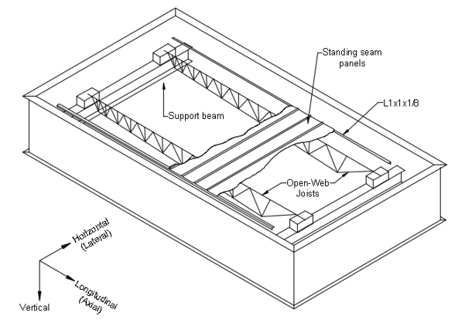

Figure 1 – Test Chamber

a) Pin | b) Roller | c) End Angle
 | 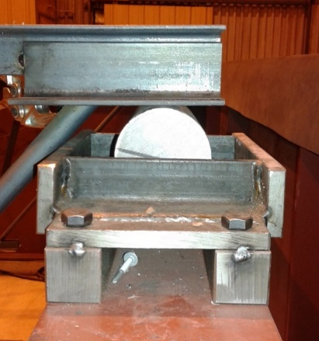 | 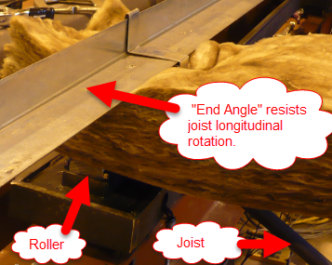
Figure 2 – Simply supported steel joist conditions including a) Pin, b) Roller, and c) End Angle

Figure No. 3 – Example of Lateral Restraint Test Device

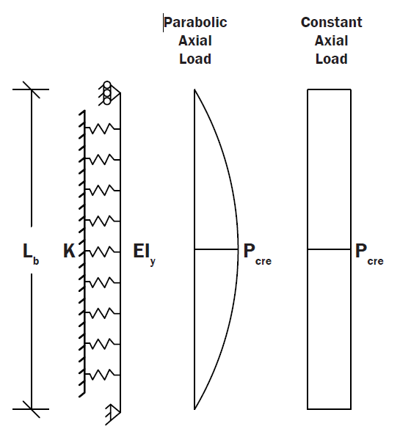

Figure 4 – Column on Elastic Foundation with a) Parabolic and b) Constant Axial Load Scenarios

Figure 5 – Plot of clip stiffness against applied pressure at failure

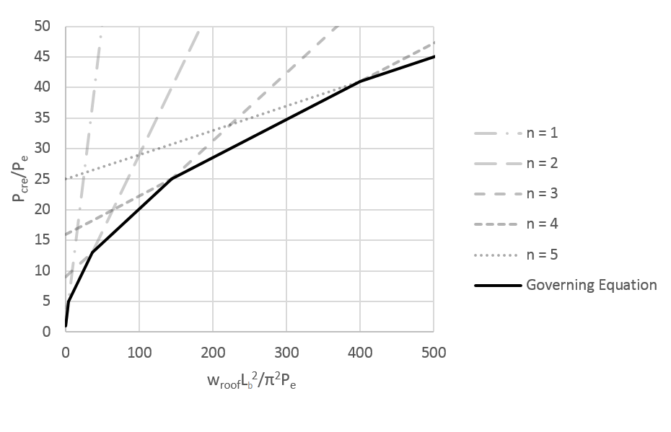

Figure 6 – P_{cre} Governing Equations where the least value governs

