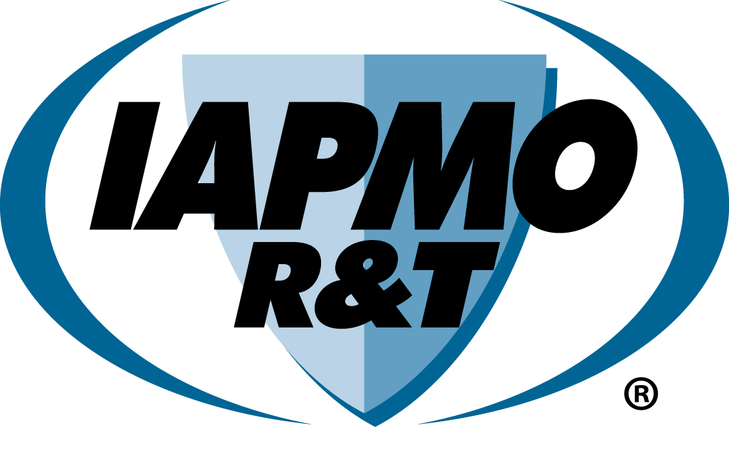

**- For 1 year duration, surveillance visit is conducted no later than 6 months and 20 days from certification date.**

**- For 2 year duration, surveillance visit is conducted no later than 12 months and 20 days from certification date.**

* **For NOM-002-CONAGUA, a QC surveillance visit is conducted no later than 12 months and 20 days from certification date and second visit at 18 months and 20 days for QC and sample selection.**

**- For 3-year duration*, surveillance visit is conducted no later than 18 months and 20 days from certification date.**

* **For NOM-002-CONAGUA, surveillance visit is conducted every 12 months and 20 days from certification date. Additionally, surveillance visits with sample selection are conducted every 12 months starting on month 18 from the certification date.**

**- For Indefinite Time *, surveillance visit is conducted at intervals of 12 months and 20 days from certification date**

* **For NOM-002-CONAGUA, surveillance visit is conducted every 12 months and 20 days from certification date. Additionally, surveillance visits with sample selection are conducted every 12 months starting on month 18 from the certification date.**

**\* If customer maintains a valid NMX-CC-9001-IMNC-2008 (or equivalent) certification.**

**Renewal file review to be conducted at a frequency based on the applicable certification duration.**

**Refer to Procedure R-092 for sample retesting details for surveillance and renewal.**

**Refer to Procedure R-072 for surveillance inspection details.**

**APPLICATIONS INCLUDE:**

* Completed application packet ~~(~~Specify duration - 1 year, 2-year, 3 years*, or Indefinite Time)

*Not available for NOM 002-CONAGUA

* Test reports
* Technical Information
* Fees
* Installation Instructions
* For 3 years or Indefinite Time - Valid Certificate to NMX-CC-9001-IMNC-2008 (or equivalent)

*R-092 provides more details.*

**\*IAPMO R & T will only issue certifications valid for one year, two years, three years**, or indefinite, respectively, in accordance with the policies and criteria of CONAGUA.**

*\*\*This duration is not available for NOM-002-CONAGUA*

Initial Plant Inspections

(For 2-year certification Only)

*\*For NOM-002-CONAGUA, Initial Sample Selection and Initial Plant Inspections are applicable for all types.*

Certification Issued and Notification to CONAGUA

Surveillance Inspection + Renewal File Review

Secondary Review and Certification Decision

**INITIAL INSPECTION:**

* Verification of Quality Control System

*R-019 and R-072 provides more detail*

Prospective Client Contact IAPMO R&T

**YES**

*Need more info from applicant*

**NO**

Report of Findings

Application Packet – Reviewed by Technical Staff & Other Staff

Application Submitted

**YES**

**NO**

Response satisfactory?

*Need more info from applicant*

**NO**

Is the inspection’s result satisfactory?

**YES**

**IAPMO R&T**

**MEXICO CERTIFICATION SCHEME FLOWCHART**