INTERNATIONAL ASSOCIATION OF PLUMBING AND MECHANICAL OFFICIALS
UNIFORM EVALUATION SERVICES
EVALUATION CRITERIA FOR
DIAPHRAGM STRENGTHENING USING FIBER REINFORCED POLYMERS
EC 038-20XX (Edited June 25 , 2019)
(Adopted ____ 2019)
- INTRODUCTION
  - Purpose: This Evaluation Criteria establishes the requirements for fiber reinforced polymer (FRP) to be recognized in an evaluation report independently reviewed and issued by an evaluation service agency under the International Building Code® (IBC), the International Residential Code® (IRC), and the California Building Code® (CBC). Basis of recognition is IBC Section 104.11, IRC Section R104.11, and CBC Section 104.11.
This Evaluation Criteria provides requirements for the evaluation of fiber reinforced polymers to supplement the requirements provided in the IBC, the IRC, the CBC, or other associated standards for these products. The reason this criteria was developed is to provide guidelines for diaphragm strengthening using FRP since the IBC, IRC, and CBC do not provide requirements for testing and determining the structural capacities, reliability, and serviceability of these products for this purpose.
This criteria may be used by design professionals to design diaphragm strengthening using FRP that complies with the prequalification testing requirements of Section 4.0. In order to demonstrate compliance with Section 4.0, a manufacturer shall acquire an evaluation report for the FRP product in accordance with Section 7.0.

  - Scope: The scope of this criteria is for using externally bonded fiber reinforced polymers (FRP) to strengthen reinforced concrete diaphragms resisting seismic motions and loadings. This criteria is applicable to wet layup FRP systems composed of high-strength fiber reinforced sheets, or fabrics, combined with a polymer resin. This criteria does not include prefabricated systems such as FRP plates, rods or near surface mounted systems. Other design requirements for strengthening concrete with FRP shall be in accordance with the IBC, ACI 318, ACI 440.2R, and AC125.
The criteria provides guidelines to calculate, test and evaluate diaphragm shear, chord and collector enhancement using externally bonded FRP. This criteria shall apply to the following diaphragm systems with existing conventional or prestressed (post-tensioned) reinforcement:

- Monolithic cast-in-place concrete diaphragms.
- Cast-in-place concrete composite topping slab diaphragms on precast floors or roofs at least two inches (51 mm) thick, provided the cast-in-place topping slab is reinforced and the surface of the previously hardened concrete on which the topping slab is placed is clean, free of laitance, and intentionally roughened.
- Cast-in-place concrete non-composite topping slab diaphragms at least 2½ inches (63 mm) thick, provided the cast-in-place topping slab is detailed for continuous seismic load path to vertical lateral-force-resisting elements.
    - Limitations and Additional Considerations:
- Measures shall be taken to mitigate thermal stresses that may develop from FRP reinforcement exposure to direct sunlight. For example, at roof diaphragm applications, shade or emissive coating may need to be provided to minimize potential for temperature elongation or shrinkage.
- Detailed considerations for the shear transfer mechanism and related diaphragm shear strength are required for untopped precast concrete diaphragms. The failure mechanism in untopped concrete diaphragms is generally not expected to follow the same assumed truss action as occurs in conventional concrete, and special consideration is required at shear transfer between adjacent precast elements and into the supporting vertical elements. Some other considerations for untopped precast concrete diaphragms may include decreased composite action due to axial shortening from shrinkage cracking at interfaces between cast-in-place concrete and precast elements as well as axial elongation in the seismic lateral-force-resisting system beams. Although there are detailing considerations provided in Section 5.0 of this criteria, this criteria does not provide comprehensive design recommendations for untopped precast diaphragms.
- Only the topped concrete portion of non-prismatic diaphragm systems shall be considered effective for seismic shear strength, such as in concrete over metal deck or waffle slab applications, unless specific component testing is provided to justify alternative values.
- The compressive strength of the existing diaphragm elements, f´_{c}, shall be a minimum of 2,500 psi (17.2 MPa).
- Care shall be provided to avoid damage to (prestressed) post-tensioned reinforcement where present in diaphragms where post-installed FRP anchorage is required.
  - Definitions: For terms not defined in this section, applicable codes, or referenced standards shall have the ordinary accepted definition for the context for which they are intended.
    - Additives: Substances added to the polymer resin to aid in processing of the FRP material.
    - Carbon fiber reinforced polymer (CFRP): A composite material comprising a polymer matrix reinforced with a carbon fiber fabric.
    - Composite: Engineering materials (for example, concrete and FRP) made from two or more constituent materials that remain distinct but combine to form materials with properties not possessed by any of the constituent materials individually; the constituent materials are generally characterized as matrix and reinforcement.
    - Embedded Fiber Anchor: A post-installed FRP anchor placed into pre-drilled holes saturated with polymer resin.
    - Evaluation Service Agency: Organization evaluating building products or finished construction for conformance to applicable codes and standards and publishing report or listing documents summarizing conclusions. The agency shall be accredited for the applicable product scope in accordance with ISO/IEC Standard 17065. The agency’s accreditation shall be issued by an accreditation body conforming to ISO/IEC 17011 and that is a signatory of the International Laboratory Accreditation Cooperation (ILAC) Mutual Recognition Arrangement (MRA) or another approved agency.
    - Fabric: A two-dimensional network of woven, nonwoven, knitted or stitched fibers, rovings or tows.
    - Fabric, Reinforcing: Continuous carbon, glass and aramid fibers are common reinforcements used in reinforcing fabrics. The reinforcing fabric provides strength and stiffness to the FRP system. The reinforcing fabric architecture may vary and may provide either uniaxial or multiaxial strength to the system. Most structural reinforcement applications will consist of a unidirectional laminate architecture.
    - Fiber-reinforced polymer (FRP): A general term for a composite material comprising a polymer matrix reinforced with fibers in the form of a fabric. Reference is made to Composite.
    - Filler: A finely divided, relatively inert material, such as silica fume, added to resin to improve workability, reduce cost or reduce density.
    - Fiber Splice Anchor: An FRP anchor used for developing tension forces either between separate FRP sheets or between an FRP sheet and concrete, usually used to transition through an existing intersecting concrete component.
    - Force-Controlled Action: An action that is not allowed to exceed the nominal strength of the element being evaluated. Force-controlled actions and their acceptance criteria are prescribed in Chapter 7.5 of ASCE/SEI 41 when this criteria is used in conjunction with ASCE/SEI 41. Force-controlled actions are classified as seismic load effects including Overstrength Factor when this criteria is used in conjunction with ASCE/SEI 7.
    - Fully Anchored: Mechanical anchorage that is capable of developing the ultimate strength of the bonded FRP laminate.
    - Glass fiber reinforced polymer (GFRP): A composite material comprising a polymer matrix reinforced with glass fiber fabric.
    - Laminate: A single or multiple plies of reinforced fabric and resin molded together.
    - Lay-up, wet: The process of on-site saturation of the reinforcement fabric with resin followed by application of the saturated fabric to the host structure to cure in-place.
    - Polymer: The product of polymerization; more commonly a rubber or resin consisting of large molecules formed by polymerization.
    - Pseudostatic: Loading that mimics dynamic loads but is slow enough that the inertial effects on the test specimen are negligible.
    - Resin: Generally, a thermosetting polymer used as the matrix and binder in FRP composites.
    - Resin, epoxy: A class of organic chemical bonding systems used in the preparation of special coatings or adhesives for concrete or as binders in epoxy-resin mortars, concretes and FRP composites.
    - Tow: An untwisted bundle of continuous filaments.
    - Unit Fiber Weight: The measured dry carbon or glass fiber weight per unit length of reinforcing fabric or fiber anchor.
  - Notation
Acv = gross area of concrete section, not to exceed the thickness times the width of the diaphragm, in.² (mm²)

AEqv = equivalent laminate area of an anchor, in.² (mm²)

Afv = area of FRP shear reinforcement with spacing s, in.² (mm²)

bw = unit width of diaphragm analyzed for strengthening, in. (mm)

bf = effective fiber design width for fiber contribution to collector element, in. (mm)

d = distance from extreme compression fiber to centroid of tension reinforcement, in. (mm)

dfv = effective depth of FRP shear reinforcement, in. (mm)

Ef = tensile modulus of elasticity of FRP, psi (MPa)

f`c = specified compressive strength of concrete, psi (MPa)

ffe = effective stress in the FRP; stress attained at nominal strength, psi (MPa)

k1 = modification factor applied to $κ_{v}$ to account for concrete strength

k2 = modification factor applied to $κ_{v}$ to account for wrapping scheme

κv = bond-dependent coefficient for shear

l_{d} = development length

Le = active bond length of FRP laminate, in. (mm)

n = number of plies of FRP reinforcement

tf = nominal thickness of one ply of FRP reinforcement, in. (mm)

Vc = nominal shear strength provided by concrete with steel flexural reinforcement, lb (N)

Vf = nominal shear strength provided by FRP stirrups, lb (N)

Vn = nominal shear strength, lb (N)

Vs = nominal shear strength provided by steel stirrups, lb (N)

εfe = effective strain in FRP reinforcement attained at nominal strength, in./in. (mm/mm)

εfu = design rupture strain of FRP reinforcement, in./in. (mm/mm)

λA = dry fiber weight per unit length of an anchor, oz./in.

γs,Exp= dry fiber weight per square surface area of a laminate, oz./in.²

ϕ = strength reduction factor

ψf = FRP strength reduction factor

θ = orientation angle of fiber – primary fiber direction

- REFERENCED STANDARDS AND DOCUMENTS
Standards shall be applied consistent with the specific edition of the code(s) for which the Evaluation Report is prepared unless otherwise approved by UES.

American Concrete Institute
    - American Concrete Institute, ACI 318-14 Building Code Requirements for Structural Concrete and Commentary.
    - American Concrete Institute, ACI 355.4-11 Qualification of Post-Installed Adhesive Anchors in Concrete and Commentary.
    - American Concrete Institute, ACI 369.1-17 Standard Requirements for Seismic Evaluation and Retrofit of Existing Concrete Buildings (369.1) and Commentary.
    - American Concrete Institute, ACI 374.2R-13 Guide for Testing Reinforced Concrete Structural Elements under Slowly Applied Simulated Seismic Loads.
    - American Concrete Institute, ACI 440.8-13, Specification for Carbon and Glass Fiber-Reinforced Polymer Materials Made by Wet Layup for External Strengthening.
    - American Concrete Institute, ACI 440.2R-17, Guide for the Design and Construction of Externally Bonded FRP Systems for Strengthening Concrete Structures.

American Society of Civil Engineers
    - ASCE/SEI 41, Seismic Evaluation and Retrofit of Existing Buildings.
    - ASCE/SEI 7, Minimum Design Loads and Associated Criteria for Buildings and Other Structures.

ASTM International
    - ASTM D3039, Standard Test Method for Tensile Properties of Polymer Matrix Composite Materials, ASTM International.
    - ASTM D4541, Standard Test Method for Pull-off Strength of Coating Using Portable Adhesive-Testers, ASTM International.
    - ASTM D7565, Standard Test Method for Determining Tensile Properties of Fiber Reinforced Polymer Matrix Composites Used for Strengthening of Civil Structures, ASTM International.
    - ASTM D7522/D7522M, Standard Test Method for Pull-Off Strength for FRP Laminate Systems Bonded to Concrete Substrate, ASTM International.
    - ASTM E575, Standard Practice for Reporting Data from Structural Tests of Building Constructions, Elements, Connections, and Assemblies.

Center for Transportation Research
    - CTR Technical Report 0-6306-1, Shear Strengthening of Large Reinforced and Prestressed Concrete Elements Using Carbon Fiber Reinforced Polymer (CFRP) Sheets and CFRP Anchors, Rev February 2012.
    - CTR Technical Report 0-6783-1, Use of Carbon Fiber Reinforced Polymer (CFRP) with CFRP Anchors for Shear-Strengthening and Design Recommendations/Quality Control Procedures for CFRP Anchors, March 2017.

Federal Emergency Management Agency
FEMA 461, Interim Testing Protocols for Determining the Seismic Performance Characteristics of Structural and Nonstructural Components, June 2007.

International Code Council
    - International Residential Code, IRC, 2018, 2015, 2012, 2009.
    - International Building Code, IBC, 2018, 2015, 2012, 2009.
    - California Building Code, CBC, 2016, 2013.
    - ICC-ES AC125, Acceptance Criteria for Concrete and Reinforced and Unreinforced Masonry Strengthening Using Externally Bonded Fiber-Reinforced Polymer (FRP) Composite Systems.
    - ICC-ES AC178, Acceptance Criteria for Inspection and Verification of Concrete and Reinforced and Unreinforced Masonry Strengthening Using Fiber-Reinforced Polymer (FRP) Composite Systems.

International Organization for Standardization
    - ISO/IEC 17011:2004, Conformity Assessment, General Requirements for Accreditation Bodies Accrediting Conformity Assessment Bodies.
    - ISO/IEC 17020:2012 Conformity Assessment, Requirements for the Operation of Various Types of Bodies Performing Inspection.
    - ISO/IEC 17025:2005, General requirements for the Competence of Testing and Calibration Laboratories, International Organization for Standardization.
    - ISO/IEC 17065:2012, Conformity assessment – Requirements for Bodies Certifying Products, Processes and Services, International Organization for Standardization.

NIST/NEHRP
    - NIST GCR 10-917-4, Seismic Design of Cast-in-Place Concrete Diaphragms, Chords, and Collectors.
- BASIC INFORMATION
  - Description: The following information and data shall be submitted for review and evaluation for recognition of concrete diaphragm strengthening using FRP materials in an evaluation report:
    - Product Description: The advanced composite material is composed of a reinforcing fabric combined with a polymer resin to make up the FRP material and may include coatings.
    - Installation Instructions: Installations shall be in accordance with the manufacturer’s applicator training program, the manufacturer’s quality control manual and any appropriate reference related to the project (i.e. ICC-ES AC178 or ACI 440.8).
    - Packaging and Identification: Packaging labels for the system shall include the manufacturer or a registered trademark, model or name of the product, size and applicable certification body logo and evaluation report number.
- TESTING AND PERFORMANCE REQUIREMENTS
4.1 Prequalification Testing: The intent of the prequalification testing is to verify the design equations and assumptions used in the engineering analysis. All or part of the tests described in this section, and any additional test identified for special features of the product or system, shall be specified. The test plan shall be a complete document.
Overall, qualification testing shall provide data on material properties, force and deformation limit states and failure modes, to substantiate the design strength equations and performance capability prescribed in this criteria. The specimens shall be constructed under conditions specified by the manufacturer, including curing. Tests shall replicate the anticipated construction details, loading conditions, support and boundary conditions expected in the building. Extremes of dimensional, reinforcing, and compressive strength parameters shall be considered. Specimens shall be loaded in both directions until the strengthening system is damaged, its capacity is reached, or the desired ultimate limit states are achieved.
At least two specimens for each loading case shall be tested except as specifically described. At least one specimen shall be tested for each critical combination of structural design strengths and deformations for each characteristic configuration of FRP system and concrete members. The specimen geometry, reinforcement, and boundary conditions, including supports, shall be consistent with those systems to be described in the evaluation report.
    - Diaphragm Shear Tests (In-Plane Shear):
      - Configuration: Specimens shall be configured to induce in-plane shear limit states or failure modes, and the specimen scale shall be approved by the evaluation service agency based on the recommendations in consensus documents such as FEMA 461 and ACI 374.2R.
      - Procedure: Prequalification specimens may be loaded (out-of-plane) to consider gravity load effects. The lateral load procedure shall consist of pseudostatic or dynamic loading in both directions to find cracking, ultimate strength and ultimate deformation. The specimens shall be loaded in both lateral directions until the strengthening system is damaged, its capacity is reached, or desired ultimate limit states are achieved. The loading procedure shall comply with a consensus document approved by the evaluation service agency (.e.g., ICC-ES AC125, ACI 374.2R FEMA 461), and testing shall demonstrate the adequacy of the FRP strengthening relative to the unstrengthened concrete element.
It shall be permitted to use experimental data from FRP reinforcement shear-strengthening of reinforced concrete structural walls to justify the shear strengthening of diaphragms, provided all other requirements in Section 4.0 of this criteria are observed.
    - Collector Tests (Tension):
      - Configuration: Specimens shall be configured to induce tension limit states or failure modes in the strengthened element, and the specimen scale shall be approved by the evaluation service agency based on the recommendations in consensus documents such as FEMA 461 and ACI 374.2R.
      - Procedure: Pre-qualification specimens may be gravity loaded to consider gravity load effects. The loading procedure shall consist of pseudostatic or dynamic loading to determine cracking and ultimate strength and ultimate deformation. The specimens shall be loaded pseudostatically or dynamically either in pure tension or in flexure such that the strengthening system is damaged, its capacity is reached, or desired ultimate limit states are achieved. The loading procedure shall comply with a consensus document approved by the evaluation service agency (e.g., ICC-ES AC125, or ACI 374.2-13, FEMA 461), and testing shall demonstrate the adequacy of the FRP strengthening relative to the unstrengthened concrete element.
It shall be permitted to use experimental data from FRP reinforcement tension strengthening of beams to justify tension-strengthening of collector elements, provided all other criteria in Section 4.0 of this criteria have been observed and beam testing has been approved for seismic applications.
    - Transfer Across Cold Joint Tests:
      - Configuration: Specimens shall be configured to induce joint-related limit states or failure modes, and the specimen scale shall be approved by the evaluation service agency based on the recommendations in consensus documents such as FEMA 461 and ACI 374.2R.
      - Procedure: The lateral load procedure shall consist of pseudostatic or dynamic loading in both directions to find cracking, ultimate strength, ultimate deformation, and failure loads. The specimens shall be loaded pseudostatically or dynamically until significant strength is no longer maintained. The loading procedure shall comply with a consensus document approved by the evaluation service agency (e.g., ICC-ES AC125, or ACI 374.2-13, FEMA 461), and testing shall demonstrate the adequacy of the FRP strengthening relative to the unstrengthened concrete element.
    - Adhesive FRP Anchorage: The design strengths and embedment depths of FRP anchorage shall be substantiated through representative testing that includes the specific anchorage system, installation procedure, surface preparation, and expected environmental conditions, based on the qualification requirements for post-installed adhesive anchors in ACI 355.4.
    - Testing Laboratories: Laboratories shall be accredited for the applicable testing procedures in accordance with ISO/IEC Standard 17025 or equivalent for the testing conducted and reported. The laboratory’s accreditation shall be issued by an accreditation body conforming to ISO/IEC 17011 and that is a signatory of the International Laboratory Accreditation Cooperation (ILAC) Mutual Recognition Arrangement (MRA) or another approved agency. Testing at a non-accredited laboratory may be permitted by the certification body, provided the testing is conducted under the supervision of an accredited laboratory and the supervising laboratory issues the test report.
    - Testing Reports: Test reports shall be submitted to the evaluation service agency for approval. Test reports shall include all the applicable information required in the applicable test standard and ASTM E575. Test reports shall document the following items at a minimum:
      - Location, the time and date of the test, and laboratory facilities.
      - Characteristics of the tested specimen and test configuration.
      - The applied loading and deformation under load, and the occurrence of any damage sustained by the specimen, together with the loading and deformation at which such damage occurred.
      - The resulting test ultimate strength, ultimate deformation, and failure mode.

Previous reports or approvals from other approved evaluation service agencies, shall be considered acceptable for satisfying the requirements of Section 4.0 of this criteria provided the approval includes the relevant seismic applications.
    - Product Sampling: The test specimens of FRP laminates shall be sampled or verified by an accredited inspection agency or testing laboratory. The sampled product shall be representative of the production ongoing after the sampling has taken place. The product specifications shall be within the tolerance limits reported in the quality documentation and the relevant standards (ASTM D3039/D7565).
4.2 Substrate Adhesion Testing: In-field quality control and assurance requirements, and related production testing for substrate adhesion, shall comply with ACI 440.2R Chapter 7 and ICC-ES AC178.
4.3 FRP Laminate Testing: Composite material properties required for design, including tensile modulus, ultimate tensile strength, elongation, etc., shall be tested in accordance with ASTM D7565 or ASTM D3039 and additional requirements in ACI 440.2R.
- DESIGN
  - Limitations: The tension design action in FRP reinforcement shall be designed as a non-ductile, force-controlled action. The criteria in this report is established for FRP composites transferring forces through a bond-line and through FRP anchorage, however FRP force transfer to alternative components, for example conventional post-installed expansion anchors, shall be permitted when the assembly is substantiated by experimental testing. Experimental testing and related reports shall meet the requirements of Section 4.1 of this criteria.
Clear spacing between FRP strips shall not exceed 5 times the strengthened element thickness. In cases where no reinforcing steel is provided in the section, the maximum clear spacing shall be 18 inches (457.2 mm).
  - Shear Strengthening of Concrete Diaphragms: The shear strength of diaphragm sections of concrete may be enhanced by FRP laminates with fiber oriented parallel to the applied shear force. For external FRP reinforcement in the form of discrete strips with defined widths, the design shear strength of an FRP-strengthened concrete diaphragm may be determined using Equation (1). The FRP failure modes shall be considered non-ductile, force-controlled actions, however the strengthened structural system shall use the appropriate ductility demand modification factors related to the system failure mode as prescribed in the retrofit standard. An additional reduction factor, ψfψ, shall be applied to the contribution of the FRP system, V_{f}, as follows: 0.85 for one or two-sided strengthening.
ϕVn= ϕ(Vc+Vs+ψfψVf) (1)
The strength reduction factor, $ϕ$, shall be taken from the retrofit standard used in the retrofit project, for example ASCE/SEI 41, or ACI 318 for shear controlled concrete elements in the context of retrofit designs using new building code provisions.
The shear contribution of the FRP, V_{f} , shall be computed from Equation (2):
For a two-sided retrofit: $V_{f}=A_{fv}f_{fe}$ (2a)
For a one-sided retrofit: $V_{f}={0.75A}_{fv}f_{fe}$ (2b)
The reinforcement area, A_{fv}, shall be computed by Equation (3):

where:
${ A}_{fv}=2nt_{f}d_{fv}$ for a two-sided strengthening scheme (3a)
$= {nt}_{f}d_{fv}$for a one-sided strengthening scheme (3b)
The effective design stress, f_{fe}, shall be computed by Equation (4):
$f_{fe} = ε_{fe}E_{f}$ (4)
Where $d_{fv}$ is the effective length of the diaphragm considered for seismic shear forces between anchoring points.
The effective design strain, $ε_{fe}$, is the maximum strain that shall be achieved in the FRP system at the nominal strength and is governed by the failure mode of the FRP system and of the strengthened reinforced concrete member and shall be computed by Equation (5):
$ε_{fe}=κ_{v}ε_{fu}≤0.004$ (5a)
for strengthening of conventionally reinforced diaphragm slabs with fully developed or fully anchored FRP reinforcement in accordance with Section 5.4 of this criteria where existing diaphragm slab reinforcement is fully developed along entire seismic load path in accordance with ACI 318 using l_{d} as the minimum development length.
or
$ε_{fe}=κ_{v}ε_{fu}≤0.0015$ (5b)
for one or two-sided applications in other cases.
The effective stress, f_{fe}, of the FRP shall be computed using Equation (6):
ffe=εfeEf≤0.75εfuEf (6)
The bond-reduction coefficient, k_{v}, shall be computed from Equations (7) through (10):
kκv=k1k2Le468εfu ≤ 0.75 (7)
$L_{e}=\frac{2500}{{{(n}_{f}t_{f}E_{f})}^{0.58}}$ (8)
$k_{1}=({\frac{{f`}_{c}}{4000})}^{\frac{2}{3}}$ (9)
$k_{2}=\frac{d_{fv}-L_{e}}{d_{fv}}$ (10)
Alternatively, the shear contribution of the FRP reinforcement, $V_{f}$, shall be permitted to be computed using Equation (11), where diaphragms have fiber bonded to one side only at an angle ≥ 75° to the member axis:
$V_{f}={0.75A}_{fv}f_{j}\sin^{2}θ$ (11)
where
$f_{j}={0.0015E}_{f}{≤f}_{fe}$ (12)
The total shear strength provided by FRP and steel reinforcement shall be limited as set forth in Equation (13):
Vs+Vf≤8f'cAbcvwd (13)
  - Collector and Chord Design for Diaphragms: FRP reinforcement is permitted for strengthening of collector elements in tension.
    - Where FRP strips are applied to the bottom of an existing concrete beam, the available width of the concrete beam shall be taken as the concrete beam width minus a minimum of 1 inch (25.4 mm) on each beam edge. Where the FRP strip is applied to the side of an existing beam, the effective fiber width, shall be taken as the clear depth under the bottom of existing slab minus 1 inch (25.4 mm) toward the bottom of the existing beam.
    - FRP laminates may be bonded directly to an existing collector element. The tension strength contribution of the fiber to the existing concrete collector element shall be computed using the effective design stress in Equation (4) and the effective fiber area as per Equation (14):
ϕTf= ϕψfψtfbfffe εfe=0.083f'cnEftf≤0.9εfu≤0.006 (14)
Where the strength reduction factor, $ϕ$, shall be taken from the retrofit standard used in the retrofit project, for example ASCE/SEI 41, or ACI 318 for tension-controlled concrete elements in the context of retrofit designs using new building code provisions.
To prevent an intermediate crack-induced debonding failure mode away from the section where externally bonded FRP terminates, the effective design strain in FRP reinforcement shall be limited to the strain defined in Equation (5a), with the value of k2 taken as 1.0
εfe=0.083f'cnEftf≤0.9εfu≤0.006
, for strengthening of conventionally reinforced diaphragm members with fully developed or fully anchored FRP reinforcement in accordance with Section 5.3 of this criteria, where existing collector steel reinforcement is fully developed along the entire seismic load path in accordance with ACI 318 using l_{d} as the minimum development length.
$ε_{fe}$ shall not exceed the expected yield strain of the existing reinforcement where FRP reinforcement is neither fully developed nor fully anchored in accordance with Section 5.3 of this criteria; or where FRP strengthening coincides with post-tensioning reinforcement, along the seismic load path. In cases where the provided existing steel reinforcement development is less than the required development length, linear reduction in design strain shall be taken based on the ratio of provided-to-required development. The design strain in the FRP shall be a maximum of 0.0015 where FRP is used to splice discontinuous existing reinforcement.
εfe
5.3.3 Collector forces shall be fully developed into the vertical elements of the lateral force-resisting system considering strain compatibility and transfer of all tensile forces from the FRP reinforcement.
5.3.4 FRP reinforcement is effective in strengthening tension design actions only and shall not be relied upon for compression strength. Collector elements shall be evaluated for compression in accordance with ACI 318 or the applicable reference standard. It shall be permitted to assume an effective concrete element width equal to the FRP strip width plus the depth of the diaphragm thickness on each side of the collector element where occurs.
  - Anchorage of FRP Laminates: Anchorage shall be provided at all termination points of the bonded laminates. Fiber Anchors shall be constructed using the same type fiber as that used in the fabric sheets being anchored. FRP anchorage may be used to transfer tensile forces from FRP laminates to the vertical elements of the seismic force-resisting system or diaphragm element. Anchors other than Embedded Fiber Anchors and Fiber Splice Anchors bonded through FRP adhesives, for example conventional post-installed anchors bonded to FRP through other means, shall be acceptable only where specific applications are substantiated by testing in accordance with Section 4.1 of this criteria.
5.4.1 Development into Existing Concrete: Anchors shall be designed to develop the full tensile capacity of the anchored FRP sheets. The following additional conditions shall be observed unless testing is provided in accordance with Section 4.1 of this criteria to justify the design values of each unique condition:
- Embedded Fiber Anchor embedment shall be a minimum of 2 inches (76 mm) past the first layer of existing steel reinforcement in the concrete component, defined from the inside face of the outer reinforcement layer.
- For the bond of the fiber anchor into concrete, the Embedded Fiber Anchors shall be embedded into concrete at an angle no less than 90 degrees from the primary orientation of the anchored fibers (Figure 5.4.2 of this criteria illustrates this condition).
- For the bond of the fiber anchor to the primary FRP strip, the maximum fan angle shall be 60 degrees from the primary orientation of the FRP fibers (Figure 5.4.1 of this criteria illustrates this condition). The orientation of the anchor fibers shall be used to determine the effective tension component in the orientation of the primary FRP reinforcement fibers.
- The Unit Fiber Weight of Embedded Fiber Anchors shall be at least 1.5 times that of the tributary width of the anchored fabric.
- The tributary FRP strip width of an embedded fiber shall be 10 inches (254 mm) maximum.
- The fiber anchor fans shall fully cover the primary FRP reinforcement sheets (Figure 5.4.1 of this criteria illustrates this condition).
- For a surface level offset, the horizontal dimension shall not be less than four times the vertical offset (Figure 5.4.3 of this criteria provides an example of Fiber Splice Anchor).
- In order to reduce stress concentrations at the edge of an anchor hole, the anchor hole shall be rounded with a minimum chamfer radius of 1.4 times the anchor hole radius, but not less than ½ inch (12.7 mm).
- The diameter of the anchor hole shall be oversized relative to the diameter of the fiber anchor based on the equivalent laminate area of the anchor. The anchor hole area shall be at least 1.4 times the equivalent laminate area of the anchor, as defined by Equation 15.

$A_{Eqv}=\frac{λ_{A}}{w_{f}∙γ_{s,Exp}}(w_{f}t_{f})$ (15)

Representative hole diameters relative to the equivalent laminate area are provided in Table 1 below:

Table 1
Hole Diameter (in) | Equivalent Laminate Area (in²) | Hole Area (in²)
¼ | 0.14 | 0.20
³/₈ | 0.32 | 0.44
½ | 0.56 | 0.79
⁵/₈ | 0.88 | 1.23
¾ | 1.26 | 1.77
⁷/₈ | 1.72 | 2.41
1 | 2.24 | 3.14
1 ¹/₈ | 2.84 | 3.98
1 ¼ | 3.51 | 4.91
For SI: 1 in. = 25.4 mm, 1 in² = 645 mm²

5.4.2 Fiber Splice Anchor Requirements: Fiber splice anchors (illustrated in Figure 5.4.3 of this criteria) shall be designed to develop the full tensile capacity of the anchored FRP sheets and comply with the following additional criteria:
- The Unit Fiber Weight of Fiber Splice Anchors shall be at least 1.5 times that of the tributary width of the anchored fabric.
- The tributary FRP strip width of the anchor shall be 10 inches (254 mm) maximum.
- For the bond of the fiber anchor to the primary FRP strip, the maximum fan angle shall be 60 degrees from the primary orientation of the FRP fibers (Figure 5.4.1 of this criteria). The orientation of the anchor fibers shall be used to determine the effective tension component in the orientation of the primary FRP reinforcement fibers.
- For a surface level offset, the horizontal dimension shall not be less than four times the vertical offset (Figure 5.4.3 of this criteria).
- Fiber splice anchors terminating onto the surface of concrete shall have a minimum development length of l_{d} in accordance with ACI 318 of the concrete reinforcement in the fiber orientation.
  - In order to reduce stress concentrations at the edge of the anchor hole, the anchor hole shall be rounded with a minimum chamfer radius of 1.4 times the anchor hole radius, but not less than ½ inch (12.7mm).

  - Special Detailing and Load Path Considerations: A complete seismic load path shall be provided from the strengthened elements to the vertical elements in the seismic force-resisting system.
- The design professional shall submit design calculations and related details to the building official for approval based on principles of mechanics for diaphragm openings, holes and penetrations.
- The design professional shall detail additional anchorage at any areas of known stress concentration or horizontal irregularities, such as the corners of large openings or re-entrant corners.
- The strengthening of each orthogonal direction shall be considered independently and shall not be assumed to contribute to the other direction.
- Use of FRP reinforcement for force transfer across cold joints or between precast panels shall have fibers resisting tension in each direction of seismic loading. For example, multiple layers of fibers may be provided at 45-degree orientations relative to cold joints. Shear strengthening of untopped precast diaphragms shall be designed such that flexibility between precast panels is negligible relative to global diaphragm shear flexibility.
- QUALITY CONTROL
  - Manufacture:
    - Quality documentation complying with the UES Minimum Requirements for Listee’s Quality Assurance System (UES-010) shall be submitted. A complete description shall be provided of the quality management system used in the factory to manufacture the FRP constituent materials.
    - A complete description shall be provided of the quality management system used in the field to inspect the installation of the FRP laminates, anchorage and related sampling of the materials for testing.
    - Inspections of manufacturing facilities are required for this product, by agencies accredited for the required tasks in accordance with ISO/IEC 17020, or ISO/IEC 17065.
  - Installation: Individual applicators shall be trained and deemed competent to prepare concrete substrates and apply the FRP System by the FRP manufacturer or accepted third-party trainer. Documentation demonstrating competency shall be made available. ACI 440.2R contains additional FRP installation requirements.
  - Inspection: Special inspection and testing are required for materials preparation, substrate preparation, and application of the FRP system. Special inspection shall comply with IBC Sections 1704 and 1705. Special inspectors shall provide written documentation demonstrating their qualifications for inspection of FRP systems in accordance with IBC Section 1704. Duties of the special inspector shall be prepared in accordance with AC178 and ACI 440.2, for inclusion in the evaluation report. Testing shall comply with Section 4.2 of this criteria, AC178 and ACI 440.2.
- EVALUATION REPORT RECOGNITION
Evaluation reports shall include the following information:
  - The manufacturer’s name, product name and the basic information set forth in Section 3.0 of this criteria for all assembly components.
  - Design provisions, including limitations, based on Section 5.0 of this criteria.
  - The following statement: Complete construction documents, including plans and calculations verifying compliance with this report, shall be submitted to the code official for approval. The construction documents shall be prepared and sealed by a registered design professional where required by the statutes of the jurisdiction in which the project is to be constructed.
  - Evaluation reports shall indicate special inspection requirements as set forth in Section 6.3 of this criteria.

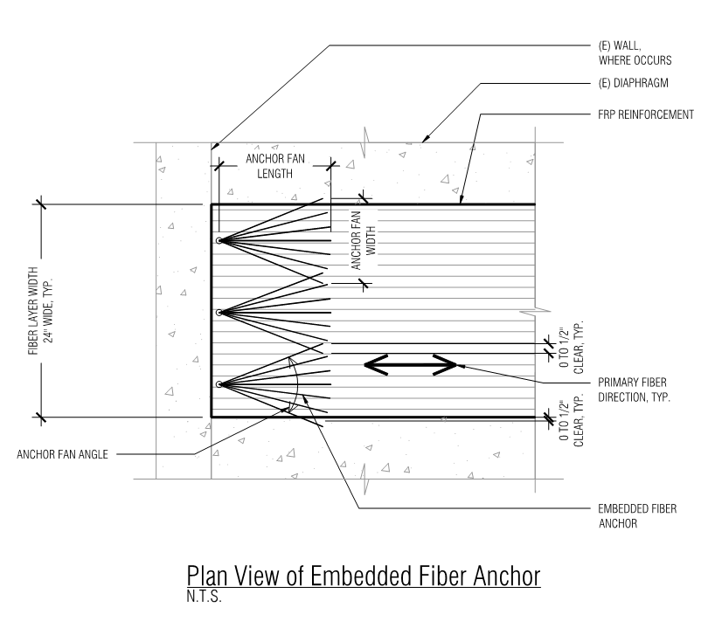

Figure 5.4.1 – Plan View of Embedded Fiber Anchor

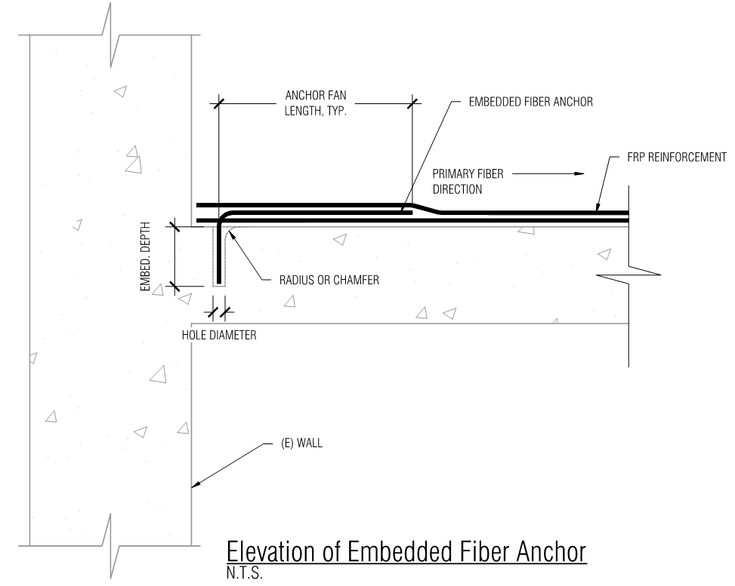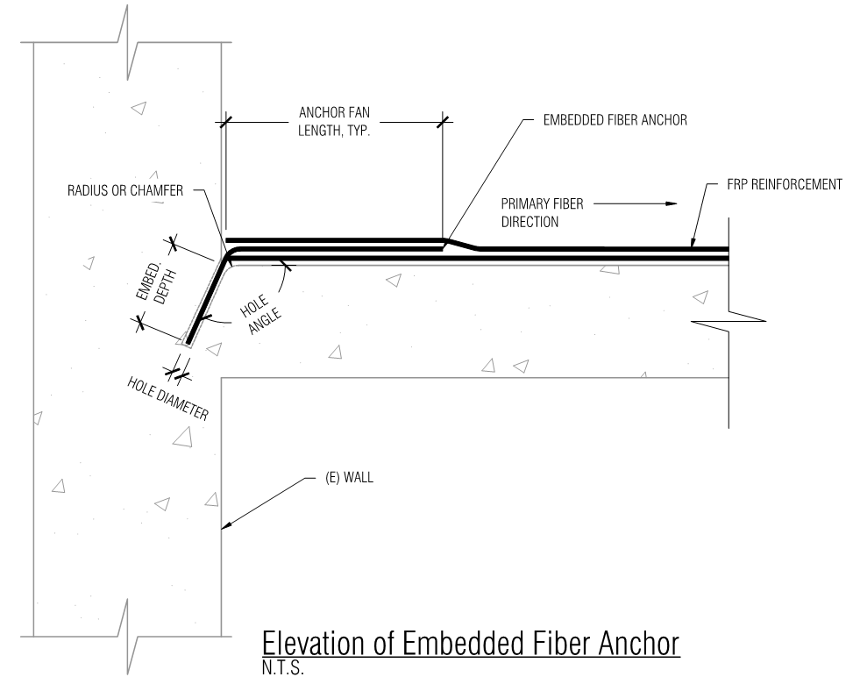
Figure 5.4.2 – Elevation of Embedded Fiber Anchor

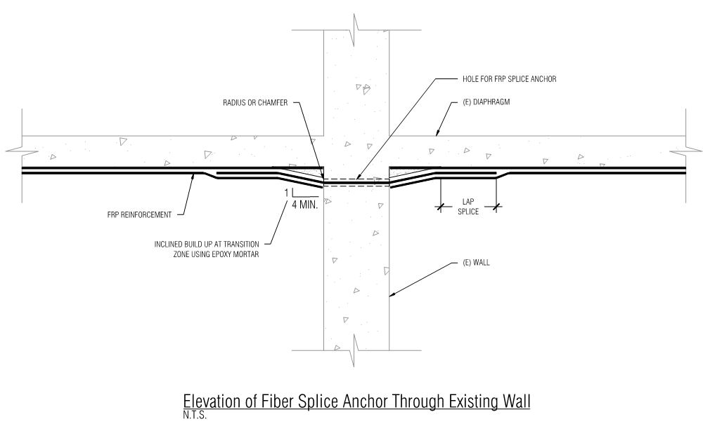
Figure 5.4.3 – Elevation of Fiber Splice Anchor Through Existing Wall

