BEST 2.2 Step-by-Step Walkthrough
Let’s get started!
The Building Efficiency System Tool or BEST software opens up to the Simple Buildings Types Wizard. This is where you can go to quickly compare the 4 most-popular (pre-selected) HVAC systems based on a selectable building type. This is perfect for a member of the design team that knows what type of building they are building but doesn’t know the first thing about the style or even terminology of an HVAC system.
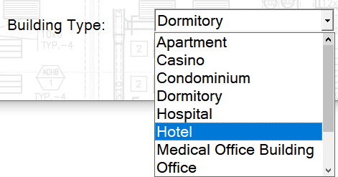
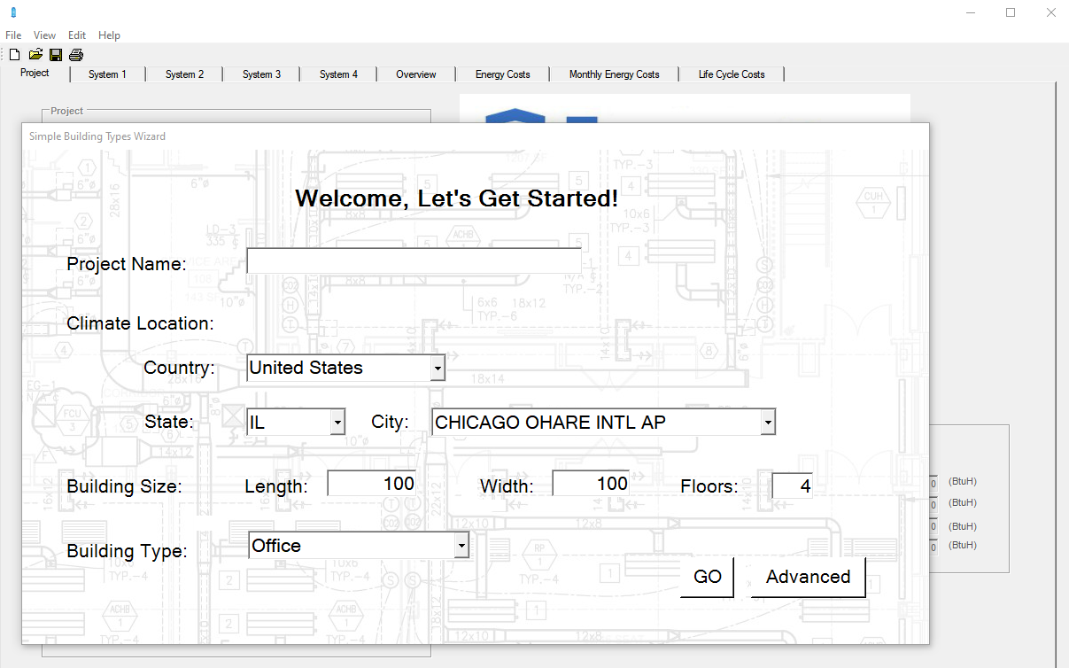
Select from 11 building types to get the
data on the 4 most commonly installed
HVAC system for that style building.
For Example:
1. Give the project a name
2. Choose a location in the US, Canada or
Mexico– I have chosen Philadelphia, PA (since
this also matches up to what was used in the
tutorial videos at HIA-C.org for consistency)
3. Enter the building length, width and floor data (e.g. length: 200 feet, width 100 feet and 5 floors)
4. Choose a building type (e.g. hotel)
5. Hit the Go button

Here are the results:
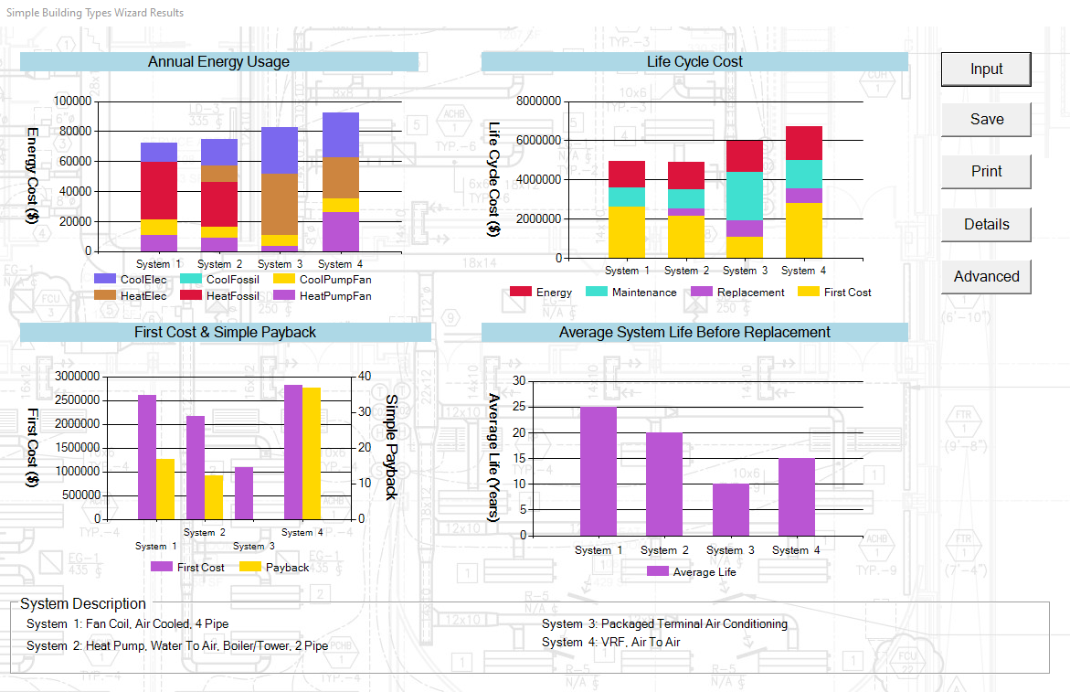
At the bottom you have the descriptions of the 4 types of systems that were modeled. If we had chosen a Medical Office Building instead of a Hotel the 4 system types would have as follows:
Note: If you click the Input button it allows you to go back to the Simple Buildings Types Wizard screen and change any of the selections.
The most pertinent data (Annual Energy Usage, Life Cycle Cost, First & Simple Payback, and Average System Life Before Replacement) is shown so the design team can start to evaluate budget and planning data for their building type in their planned building location.
This Simple Building Wizard also acts as a jumping off point to start getting into the more powerful and customizable features of the BEST tool.
From this screen hit the ADVANCED button to get to the main Project Page, which looks like:
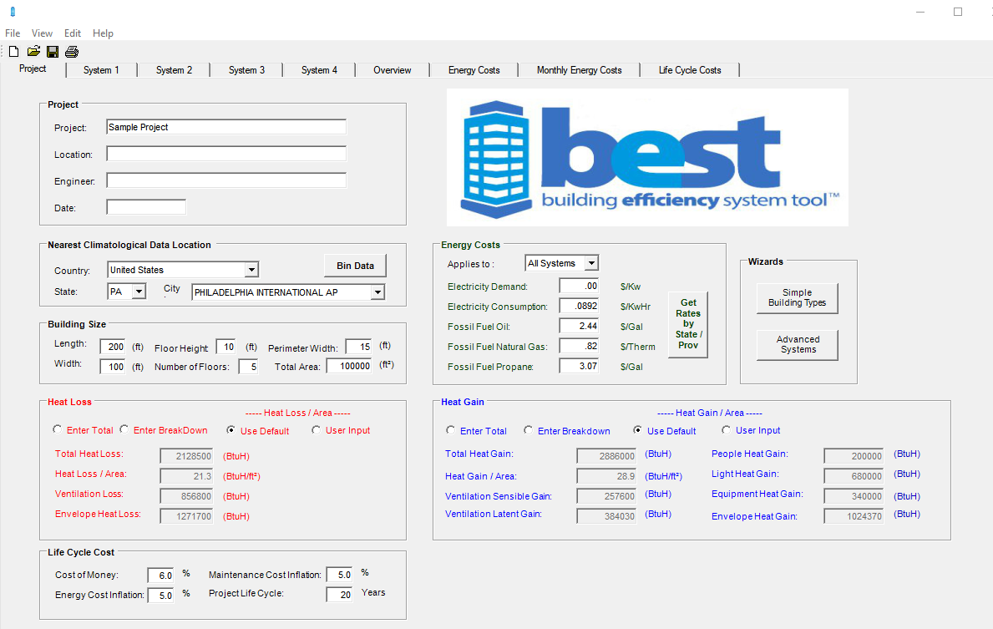
To make things easier, you will notice that the project data we typed in on the Simple Building Types Wizard page has migrated over to this page. Also default Heat Loss and Heat Gain data has been automatically entered based on the location selected. If you change location, the heat loss and heat gain data is automatically updated based on NOAA weather data using a BIN methodology.
This is also a good place to mention that although we have inputed defaults to make it easier and faster to work with the BEST tool, almost any box can have their data changed manually if you prefer or have specific information about the job or equipment planned to be used on the job.
For example if you’d prefer to use 25 BtuH/Ft² of heat gain instead of the 28.9 default, just click on the user input radio button, enter “25” into that data field and everything will update automatically. Notice how the total heat gain goes from 2,886,000 BtuH to 2,500,000. All the output data that we will view later also changes. You can also enter the data as a total heat gain or even enter the breakdown between sensible and latent gain if you know it as well. You can also then just click the Use Default radio button to go back to where we started.
Let’s go ahead and make some updates to this building to practice inputting data. In the Building Size box let’s change the floor height to 14 feet and the perimeter width to 12 feet. The perimeter width allows you to model a different system on the perimeter or skin of the building by entering the distance from the outside wall that’s effected by the skin load of the building. This is also a good example of how there are many advanced, yet still simple to use, features for all levels of users in the BEST tool.
BEST also has defaults for energy costs based on the climatological zone chosen. Note the new feature in BEST 2.2 asks if you want to default these costs to all systems. If not, then you can go to any of the four System tabs at the top, choose one and then go to the Preference box (bottom middle of the page). Click Preferences and then you will get a screen (below) which lists all of the parameters which can be selected to apply to a specific system instead of universally across all four systems being compared. This is helpful when you want to compare two identical systems but maybe see the effect of selecting a more efficient piece of equipment, holding supply and return temperature differentials to a tighter delta, or modeling different fuel cost scenarios (i.e. current vs estimated future costs). Note that at any point you can reset any changes you made back to the default settings by hitting the Reset to Defaults button in the bottom right of the screen.
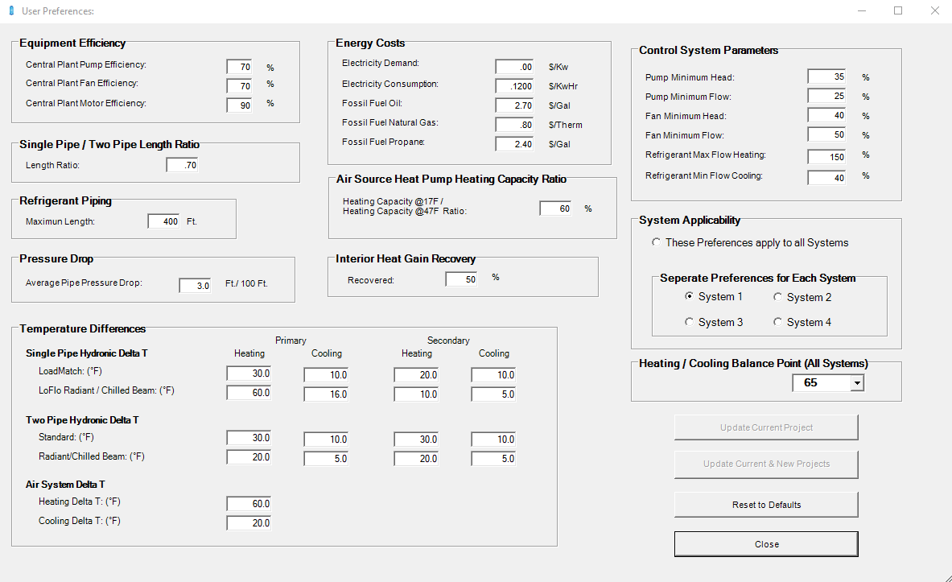
While we are discussing default parameters is good to understand how these were determined and why. Why is easy – we wanted to make this software easy and fast to use by the widest amount of people who are involved in building a building (i.e. the design team or asset managers) and not just an expert HVAC engineer / designer. However, we also wanted to give that HVAC expert all the flexibility to customize the information to match as much as possible to what is known about the building and its HVAC design. “How” the parameters and defaults were chosen was based on a broad group of manufacturers, engineers and system experts from across North America who reviewed all the data and tried to come up with the best possible starting point. The good part is that the data can be used across all the projects so each style system can be compared using the same base criteria. After more is known about a project, such as the actual efficiency of a piece of equipment, like a boiler, that can then be added to make the calculations even more accurate to the project.
If someone is interested in the details of the calculations everything is completely transparent. Open the help tab at the top of the program, under introduction there is a section on methodology which details everything. What to know how horsepower is calculated based on actual system parameters and not rules of thumb of horsepower/gpm or horsepower/cfm it’s all there, for example:
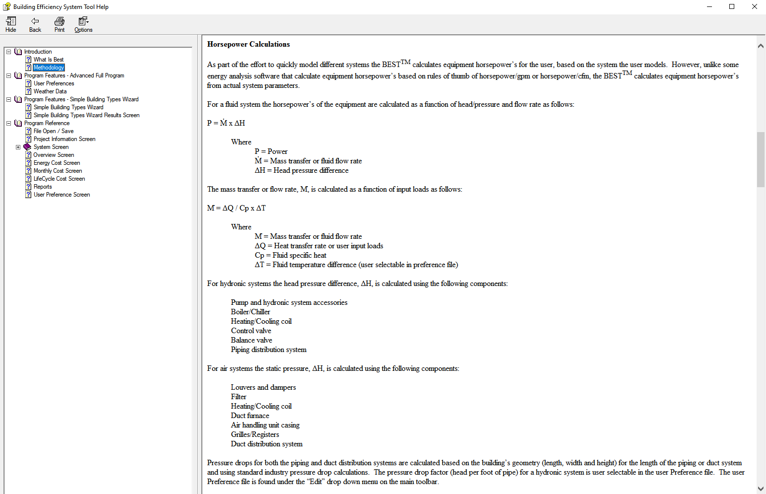
OK, let’s get back to working with the program and look at the System pages and what information is there: BEST organizes its system tabs in an easy-to-understand format starting at the left with generation sources for heating and cooling, the center is your distribution system piping ductwork, and on the far right are choices for terminal equipment. Again, any of these fields can be changed to fit what you know about the system or any specific performance details about the equipment being used.
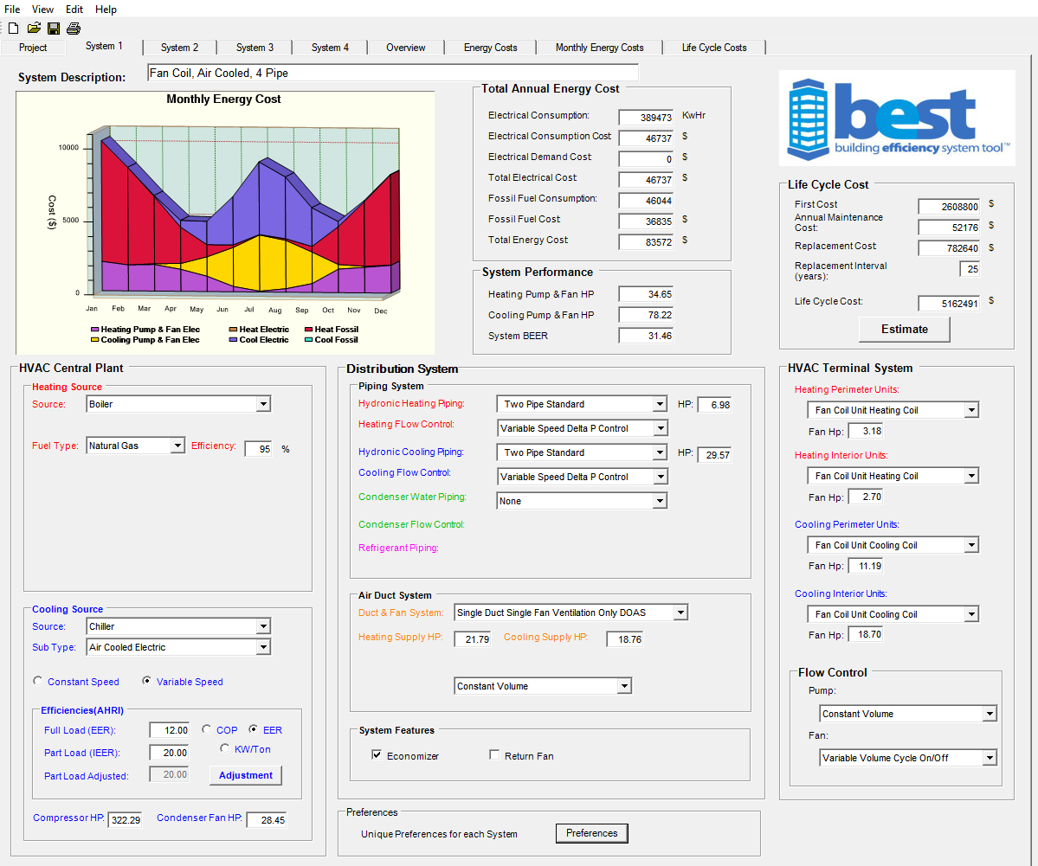
Generation
Sources
Distribution
Sources
Sources
Terminal
Equipment
Above these three columns the cost results have been published, so you can see the estimated electrical consumption, estimated fossil fuel consumption and estimated electrical fuel and energy costs.
Another powerful feature of best allows you to do a life cycle estimate. If you click the Estimate button now you can choose from a list of predefined systems to estimate the first cost. These first cost estimates are derived from data provided by over 50 major contracting firms across North America and represents typical HVAC costs.
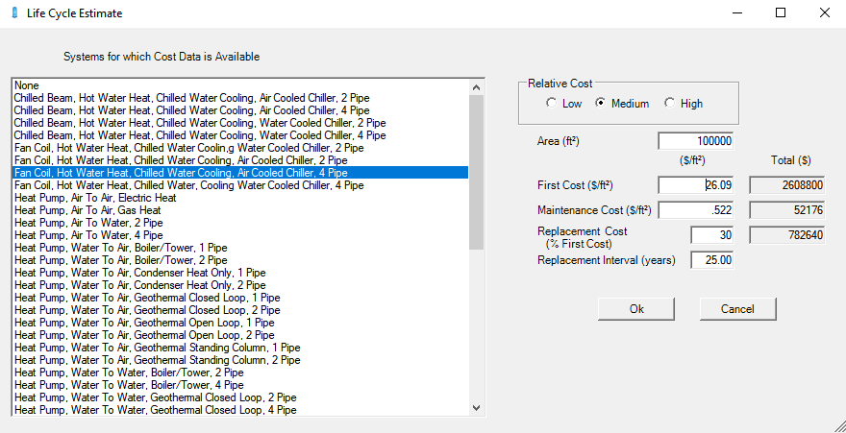
Of course the costs in New York City are different than Oklahoma City but the relative costs between different types of systems was remarkable consistent across North America. Depending on your location you can choose High, Medium, or Low and the estimates will adjust accordingly. Also, if you happen to be a design build contractor and have a good handle on your costs per square foot then just go ahead and enter your own value. Just like everything else with this program – we start with defaults to help out the user but allow for complete customization when desired. This is also the place to change the interval between system replacement which goes into the payback analysis. This data is straight out of ASHRAE publications but again, change it at will.
From here let’s look view a summary of the energy information by navigating to the energy tabs. Go ahead and close the Life Cycle Estimate screen by hitting the OK or Cancel button so you are back to the System 1 main page. You will notice 4 tabs that appear to the right of the 4 System tabs at the top of the page. This is your comparative data tabs between the four systems.
Since we were just looking at energy costs for system 1, let’s click on the Energy Costs tab to see how system 1 compares to the other systems chosen. On the left hand side of this page are the same energy details we just looked at but now you can see how all four systems selected stack up to each other and the bar chart gives a nice visualization of what the total costs are comprised of. It’s easy to see the difference between systems 1&2 which primarily use fossil fuels for heating versus systems 3&4 which use electricity (red vs brown sections) and the relative expense in actual dollars. As a reminder, the details on the 4 system descriptions is in the bottom right of the screen.
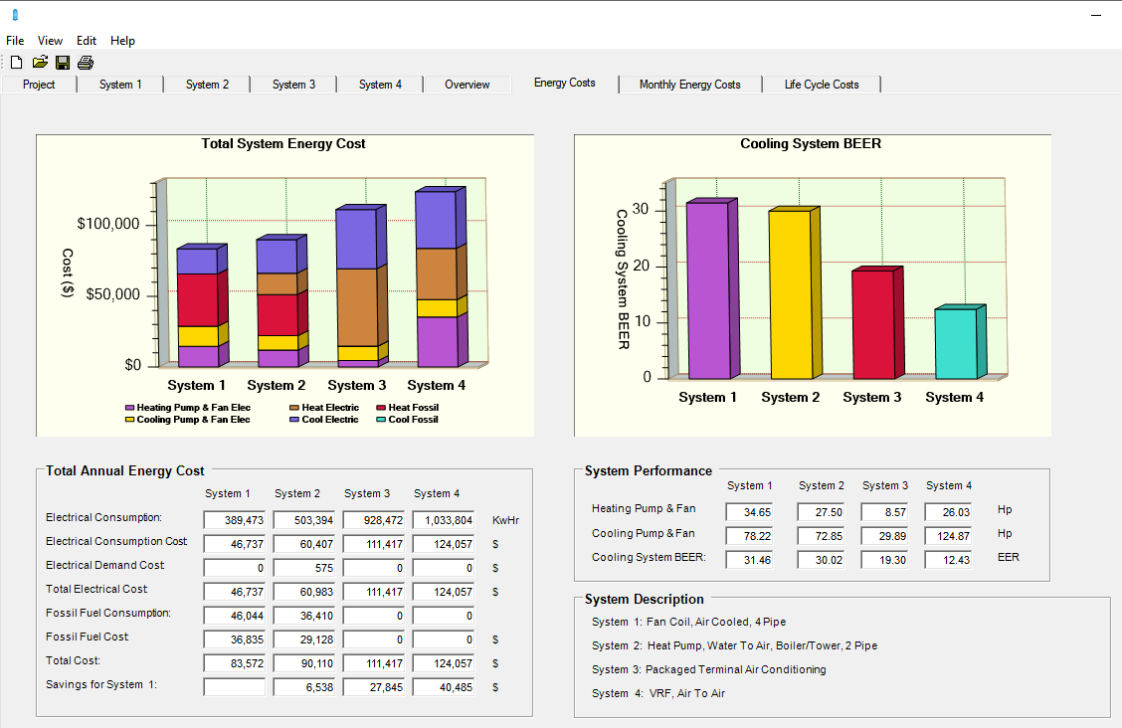
The right side of this screen if the BEER rating. BEER stands for Building Energy Efficiency Ratio. The BEER ratio is based on real world data, not just AHRI equipment testing data which comes out of a controlled laboratory setting with test conditions that don’t match real world operation conditions. Such as target air outlet temperatures of 80°F – who wants there office thermostat set at 80°? It also accounts for the missing energy consuming components in a system. BEER is the building EER as opposed to an equipment EER. It is the annual cooling required by the building divided by the annual work to create this cooling or:
BEER = Cooling Out_{annual} / Work In_{annual}
**The BEER rating, for the first time, gives you a consistent comparative rating for any HVAC system as applied in an actual building.**
It does this by adding in the energy sources that are part of a building’s HVAC system in order for it to operate but are not included in the equipment’s AHRI lab testing / certification. There is a wide difference in AHRI test standards for what’s included and what’s not included in the ratings. This is because each standard is developed by a group of manufacturers for that particular piece of equipment and testing reflects comparisons between only that type of equipment. But in the market most people think every IEER is the same and one style of equipment can be compared to another as long as both have an IEER – but this is not the case, not all IEER’s are created equally. Here’s an example of some of the energy sources included or not included by test standard:
The BEER ratio takes all this into account by adjusting the energy sources not included so every system is being compared apples-to-apples:
For more information on the BEER ratio please see the help file or visit www.HIA-C.org to view the white papers and presentations on this topic. New in BEST 2.2 is an even more detailed energy cost analysis that can now be changed by system and viewed as cost data or consumption data. This is a nice feature when you are comparing two systems that have very similar equipment but for example you are comparing the difference of purchasing a more efficient piece of equipment and you want to see if the price difference is worth the upgrade in efficiency. The screen looks like:
For Cost Data: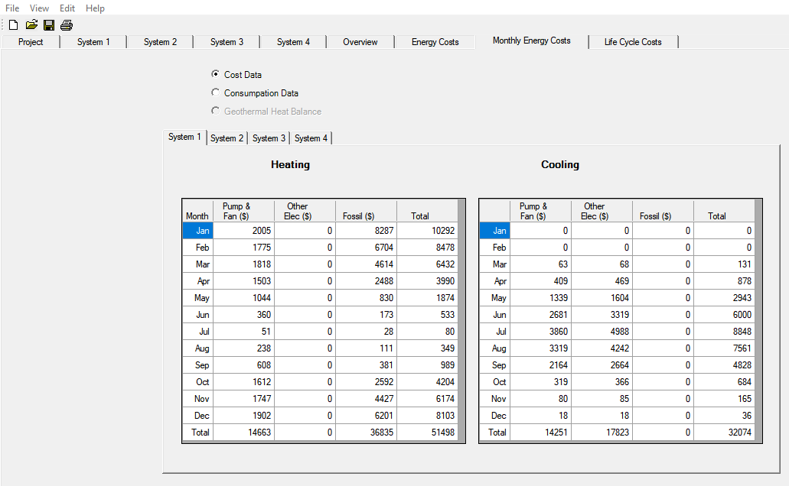
And for Consumption Data:
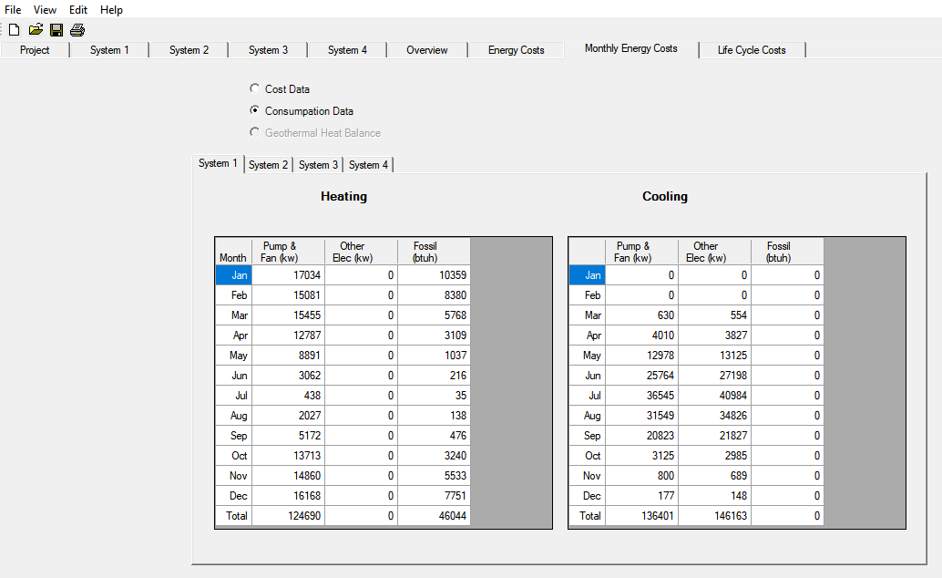

Now back to the BEST software and the other summary screens. Let’s go ahead and scroll through them by first clicking on the Overview tab.
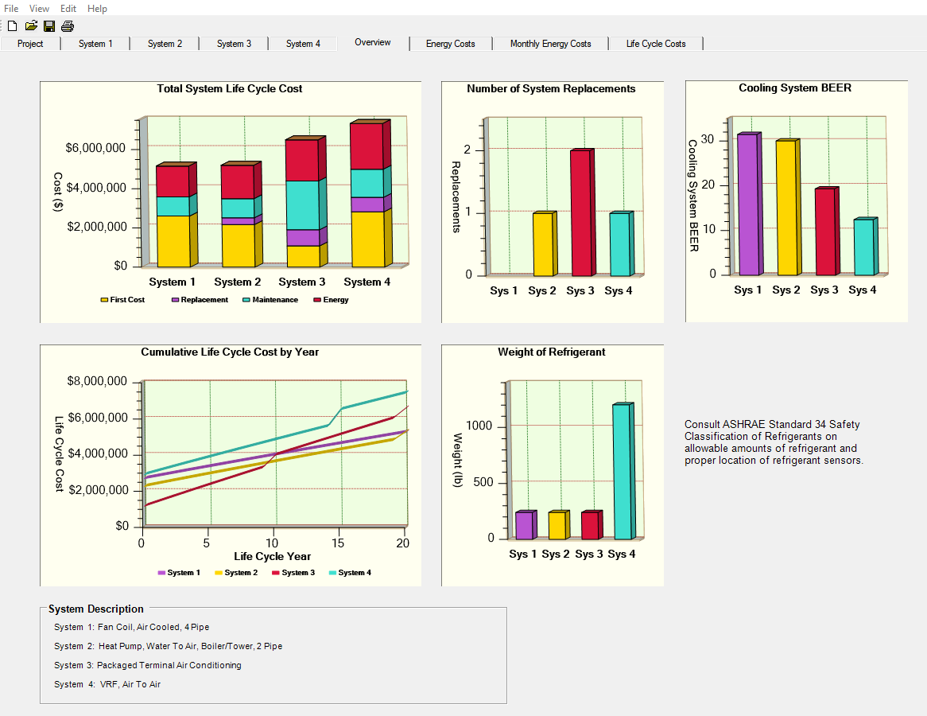
Here we can view the Total and Cumulative System Life Cycle Costs, The Number of System Replacements based on ASHRAE life estimates, the Cooling System BEER rating we just discussed, and the Weight of Refrigerant in the system. This last one is very telling as most people don’t realize the true amount of refrigerant that is being piped around a building in a VRF system compared to typical air conditioning units with a factory charged, tested and sealed refrigerant design.

Scrolling across, we’ve already looked at the Energy Costs and Monthly Energy Cost tabs so the final one is Life Cycle Costs:
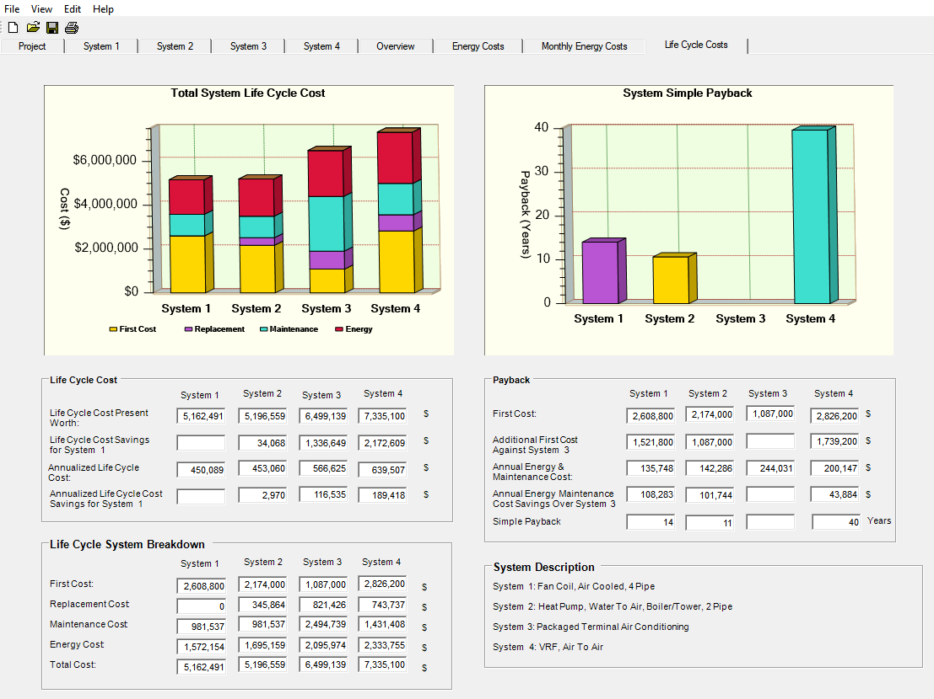
Note on this page there are some blank squares, this indicates that the system is the lowest cost system and is being used as the baseline for differential costs of the other systems. For instance, System 3 has the lowest estimated first cost (see top right data chart) and system 1 has a first cost that’s estimated at $1,521,600 more than system 3. However, if you look at the top left data field you’ll see that the total lifecycle cost for System 3 is $1,336,649 more than System 1. So this can help a building owner and design team evaluate what’s most important for them. Are they building and owning/operating the building for life or are they building and flipping the building? All these data points can help a design team have more valuable discussions about the role and impact of and HVAC system design choice.
Data Entry
There are three ways to enter system data into the BEST tool. We have used the Simple Building Types Wizard in the examples above but the other ways to enter data are through the Advanced System Wizard or fully manually. When you first open the program and the Simple Building Types Wizard screen pops-up, don’t enter in any information and just hit the “Advanced” tab. Then you go to the main screen and all the project data is blank. Click on System 1 and all is data is blank there as well.
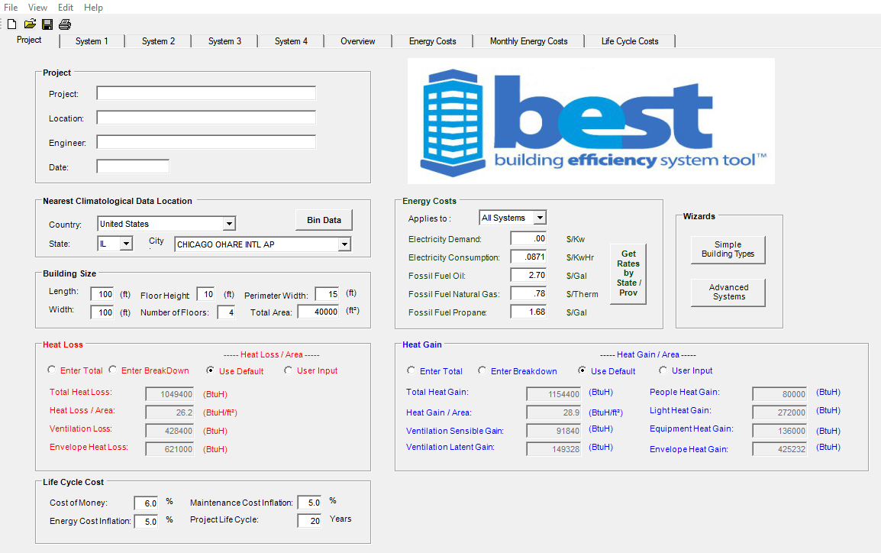
The second easiest way to select systems for comparison is to click on the Advanced Systems button in the Wizard box in the middle right of the screen. When you do this 30 preconfigured system options are available to choose from. This is important because this is also the scope of the systems which have contractor cost data available for them. Just use the drop down menus to pick the type of system, generation source and type of piping, if appropriate:
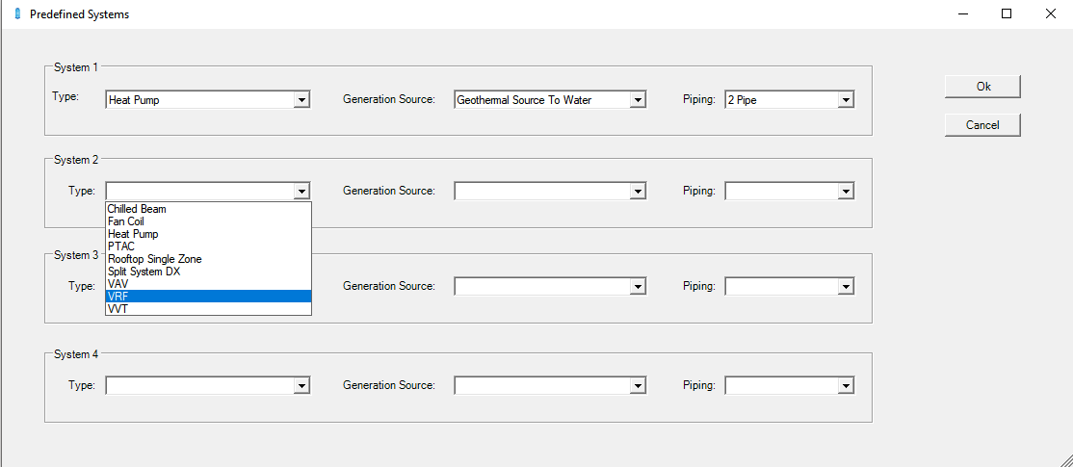
Once you have the systems you’d like to compare chosen then click OK. You can now go through all the system and overview screens just like before to compare the four systems:
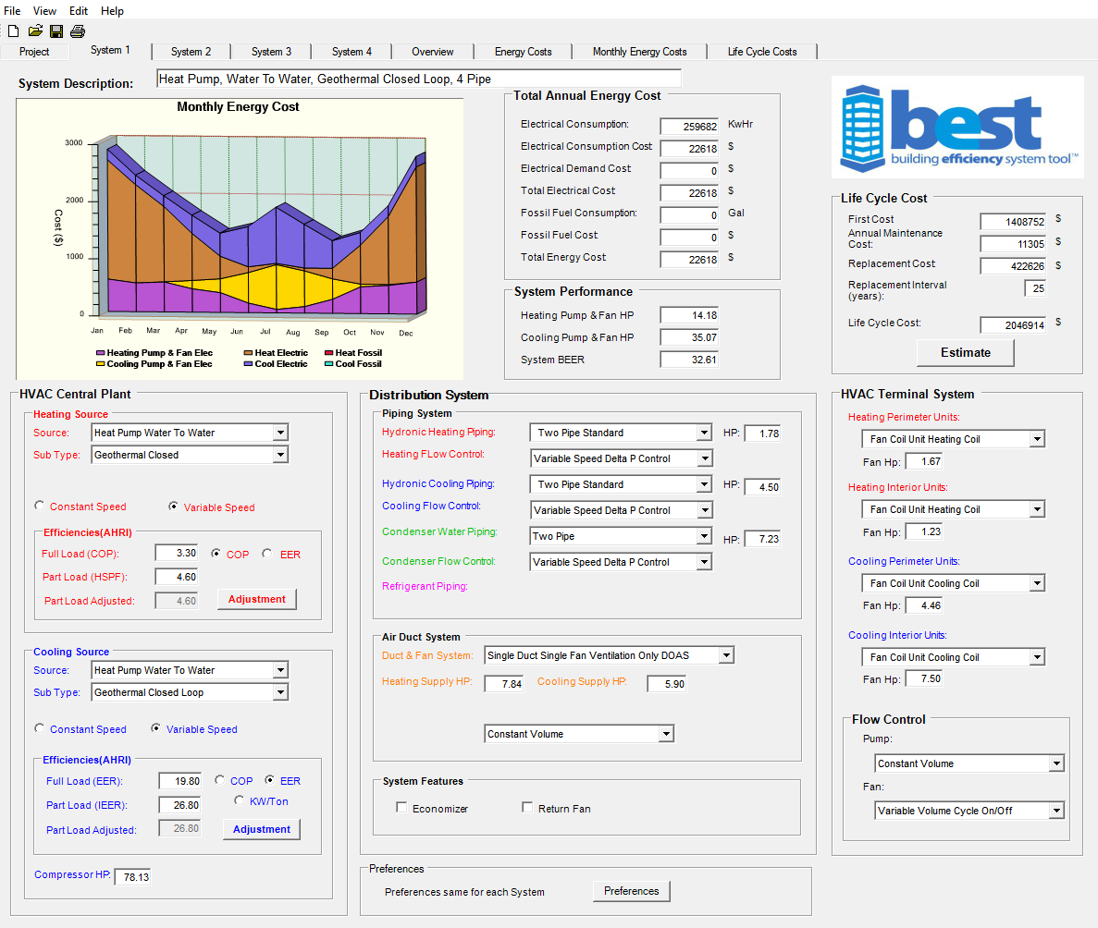
The final way to input the data is again by choosing advanced in the start-up / pop-up Simple Buildings Types Wizard screen and then going to System 1 tab and manually entering in all the information about each system using the drop down menus. This makes the program and comparisons completely customizable but you really do need to have a good working knowledge of system types, different equipment and their specifications.
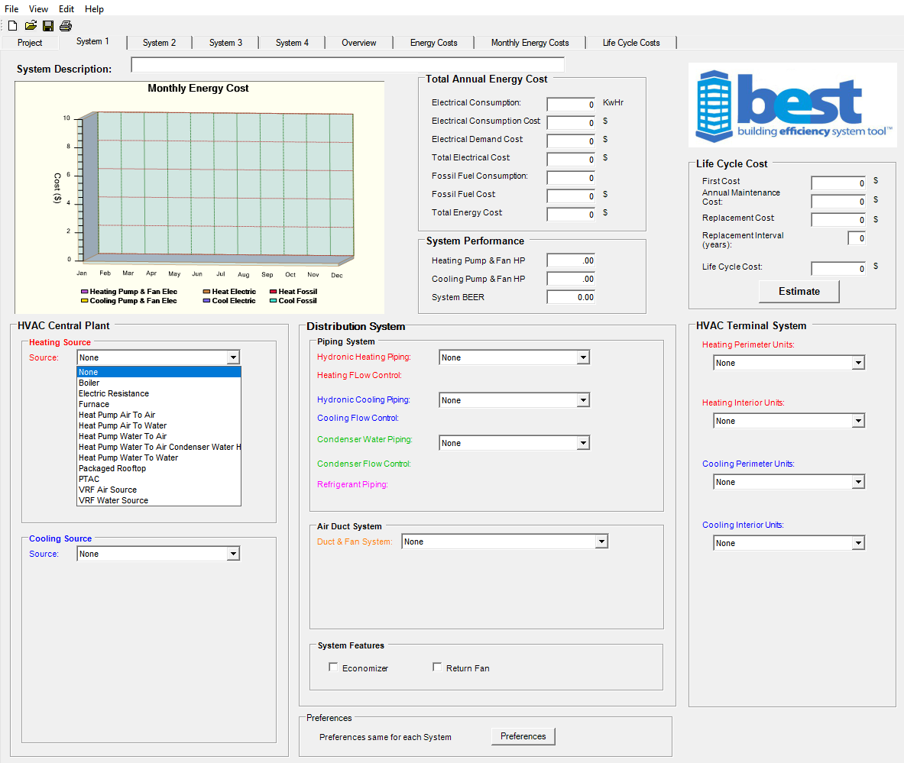
Finally, exporting the data to share with a design team as a pdf or (new to version 2.2) into an excel format for additional formatting and easier transition to other programs or documents.
From any tab go to the top menu under File and select Print / Export Reports:
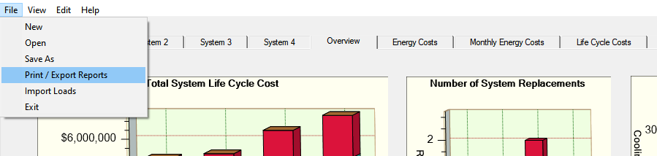
Now just check off which reports you’d like to print (save as pdf) or export to Excel. Here’s what it looks like for a printed System Overview Report and then the same exported to Excel:
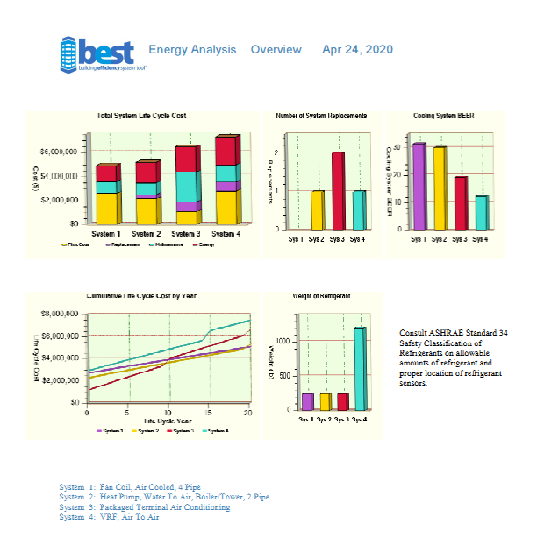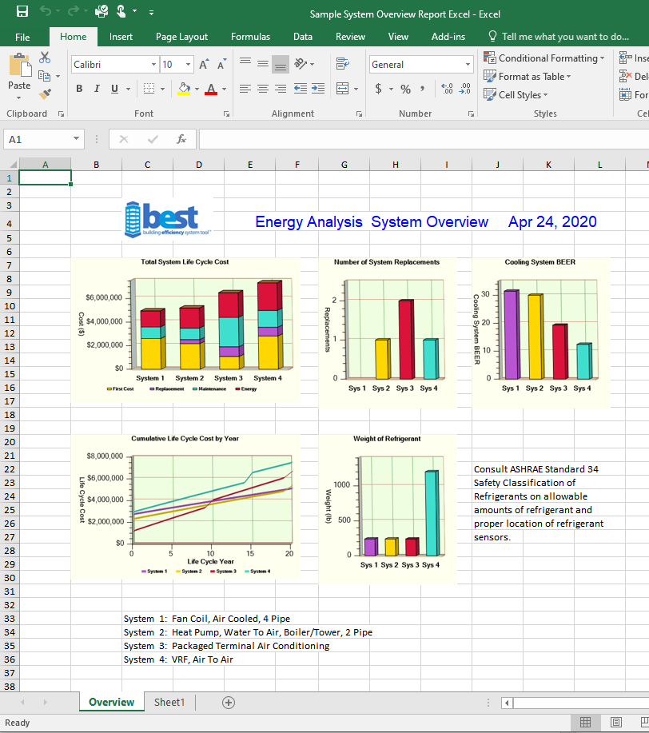
The best thing about the excel report is that it allows you to easily change the headers, rearrange the data tables, add in your own logo or information or just cut-and-paste the data to other programs or presentations. Certainly a handy upgrade to an already powerful tool!
For video tutorials on BEST from getting started to using the more advanced features make sure to check out www.HIA-C.org.

